Susan Weinschenk

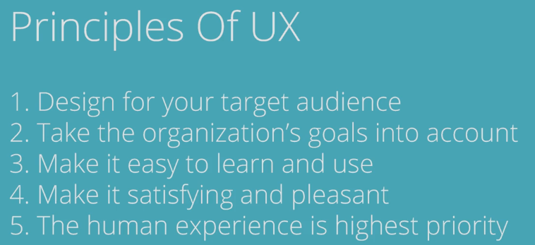

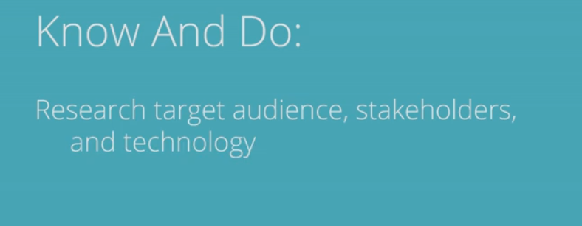

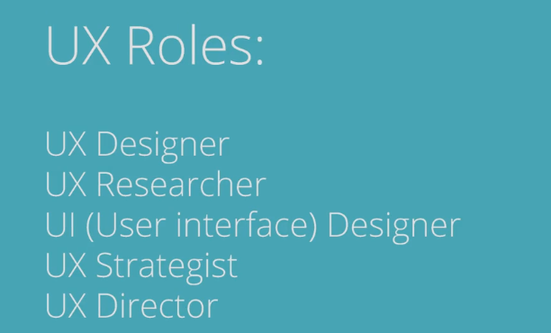

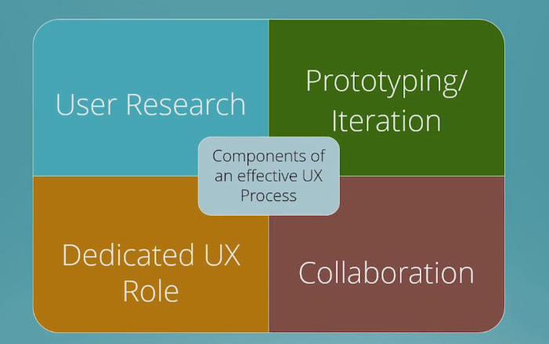

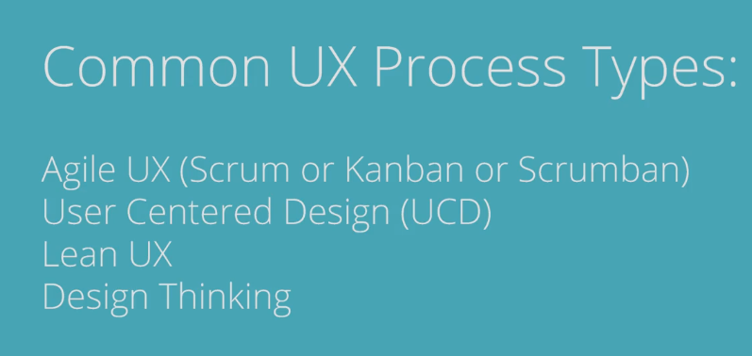

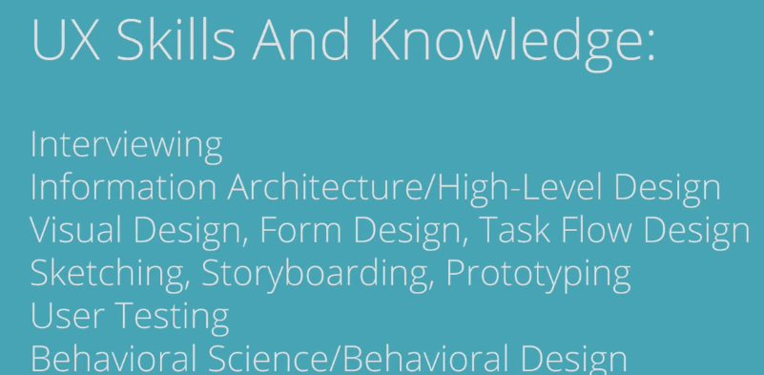

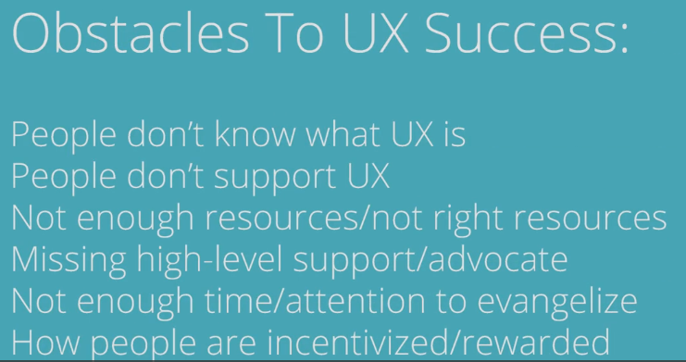

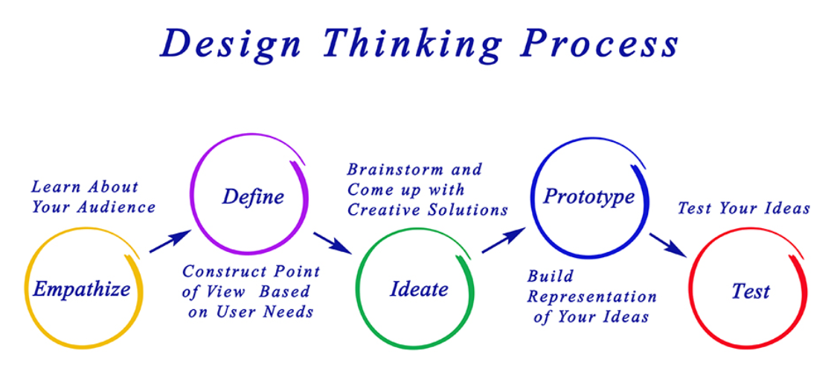

**THE DESIGN PROCESS CONSISTS OF 6 STEPS:**

1. Define the Problem

You can’t find a solution until you have a clear idea of what the problem is.

2. Collect Information

Collect sketches, take photographs and gather data to start giving you inspiration.

3. Brainstorm and Analyze Ideas

Begin to sketch, make, and study so you can start to understand how all the data and information you’ve collected may impact your design.

4. Develop Solutions

Take your preliminary ideas and form multiple small-scale design solutions.

5. Gather Feedback

Present your ideas to as many people as possible: friends, teachers, professionals, and any others you trust to give insightful comments.

6. Improve

Reflect on all of your feedback and decide if or to what extent it should be incorporated. It is often helpful to take solutions back through the Design Process to refine and clarify them.

Scrum is a framework within which people can address complex adaptive problems, while productively and creatively delivering products of the highest possible value.

Scrum itself is a simple framework for effective team collaboration on complex products.  Scrum co-creators Ken Schwaber and Jeff Sutherland have written [The Scrum Guide](http://www.scrumguides.org/) to explain Scrum clearly and succinctly.  This Guide contains the definition of Scrum. This definition consists of Scrum’s roles, events, artifacts, and the rules that bind them together.

Scrum is:

* Lightweight
* Simple to understand
* Difficult to master
* Scrum is simple.

It is the opposite of a big collection of interwoven mandatory components. Scrum is not a *methodology*. Scrum implements the scientific *method* of empiricism. Scrum replaces a programmed algorithmic approach with a heuristic one, with respect for people and self-organization to deal with unpredictability and solving complex problems. 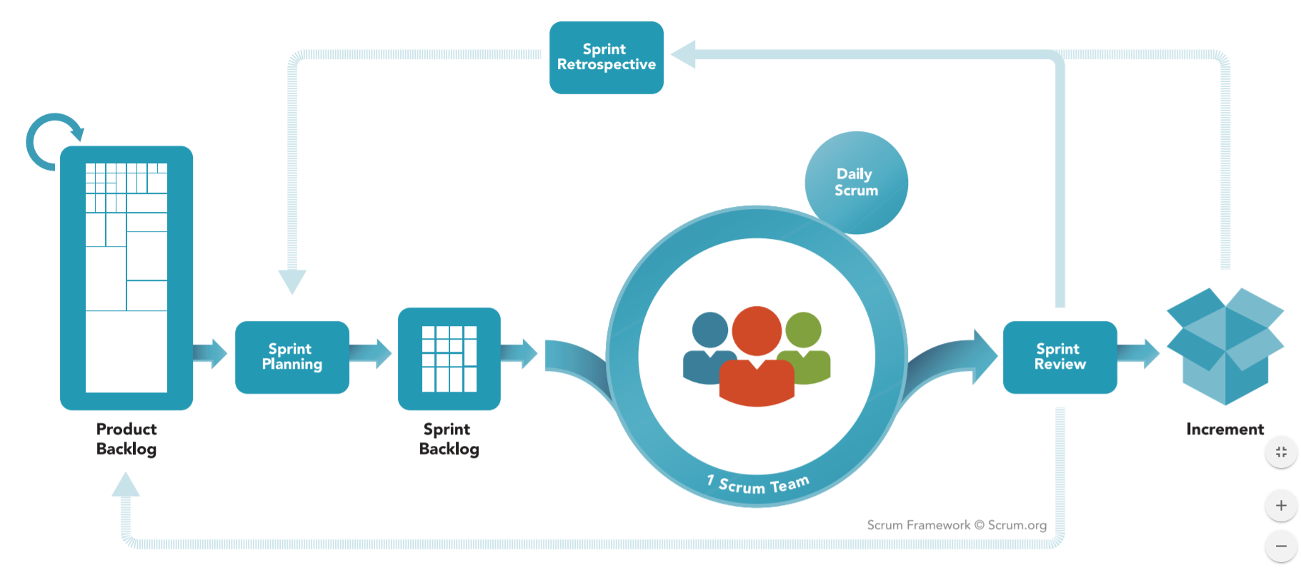

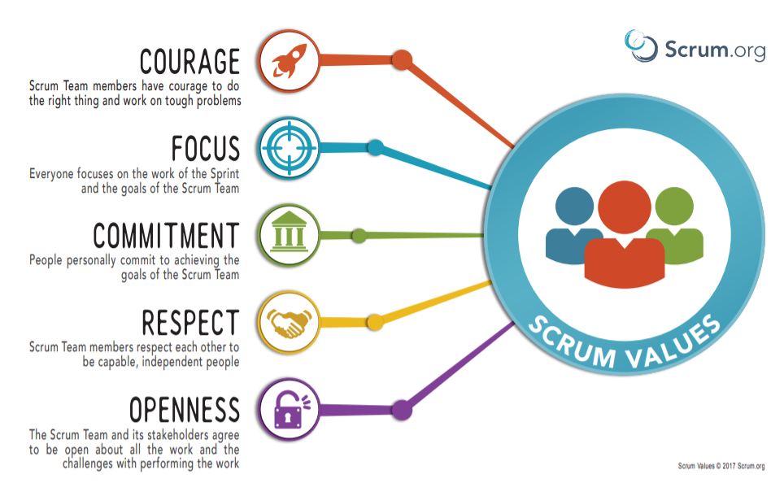

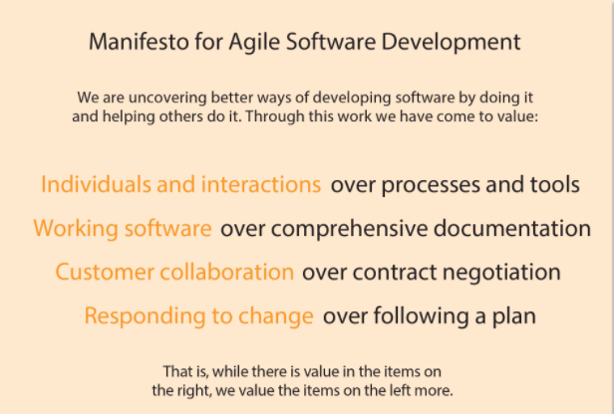

**Individuals and interactions over processes and tools**  
  
In an Agile project, great emphasis is placed on the team. Every individual in the team is expected to be ready, willing and able to play their part in the project, carrying out their role with competence and professionalism. Every member of the team is expected to work collaboratively with everybody else, using his or her knowledge, experience and judgement to shape a project outcome that best meets the need of the sponsoring business. Processes and tools play an important part in any project but much less emphasis is placed on these in an Agile environment. Agile processes need to be light touch and serve to guide and support rather than dictate what individuals and teams do and how they should do it. The assumption is that the team is best placed to understand what needs to be done and to work out the best way of doing it. DSDM provides appropriate light touch guidance on roles and responsibilities, whilst keeping the emphasis at all times on the people and the way they work together.  
  
**​Working software over comprehensive documentation**  
  
The choice of words used here reflects the origins and primary focus of Agile – a focus solely on software delivery. However, changing a single word - “software” to “solution” - elevates this value from delivery of a software product to encompass the broader context of business change projects and often this is the interpretation for DSDM. DSDM has been proven to work equally well for non-software projects.

The message behind this Agile value is to break the illusion of security and stability that comes from document-driven processes. Specification of every detail of requirements, solution design, plans etc. in documents that get ‘signed off’ by stakeholders before work is allowed to progress is both wasteful and ineffective. DSDM embraces the need for high-level versions of these artefacts in the early phases to frame development and delivery projects and to support governance. After the Foundations phase in a project, the framework employs collaborative techniques with active business engagement to ensure that the right solution is delivered. The framework also advocates light and timely documentation to support the solution in production beyond the end of the project.  
  
**Customer collaboration over contract negotiation**  
  
This Agile value encourages project teams and the sponsoring business to work collaboratively at all times. Typical commercial contracts assume that a traditional Waterfall process underpins development and ‘a fixed price for a fixed specification’ is the standard for project contracts. Agile projects emphasise collaboration, and therefore contracts need to reflect this.  
  
A contract can be as formal as a document signed by those responsible for sponsoring the solution and by those delivering it, or as informal as a shared verbal agreement on what is to be delivered. Regardless of formality, it is important to ensure that, where created, all parties follow the principle of such documents or agreements being ‘light touch’ and ‘guiding’ rather than being ‘detailed’ and ‘prescriptive’. By this definition, DSDM’s Prioritised Requirements List may represent a contract, effectively defining the scope of a project. However, as it is at a high level, it requires customer collaboration with less formality to expand on the detail of requirements throughout the iterative development of the solution during the project lifecycle.  
  
**Responding to change over following a plan**  
  
This Agile value emphasises the fact that the world around a project is rarely frozen in time. Change occurs so quickly in the world of business now. That adopting an approach to building a solution which accommodates, or ideally embraces, change is likely to be the only way to a successful outcome. Change may also arise as a result of an emerging understanding of what is needed, what is valuable and even what is possible. The degree of change in detail that is typical of most projects makes creating detailed, long-term plans a waste of time. Where change is normal rather than the exception, the high-level ‘light touch’ and ‘guiding’ plans advocated by DSDM better meet the need of a flexible business.

**And the very important final sentence**  
  
The DSDM Agile Project Framework specifically embraces the last sentence in the Agile Manifesto that clearly states, in the context of the values above  
  
**“That is, while there is value in the items on the right, we value the items on the left more.”**

Dynamic systems development **method** (**DSDM**) is an agile project delivery framework, initially used as a software development **method**. First released in 1994, **DSDM** originally sought to provide some discipline to the rapid application development (RAD) **method**.

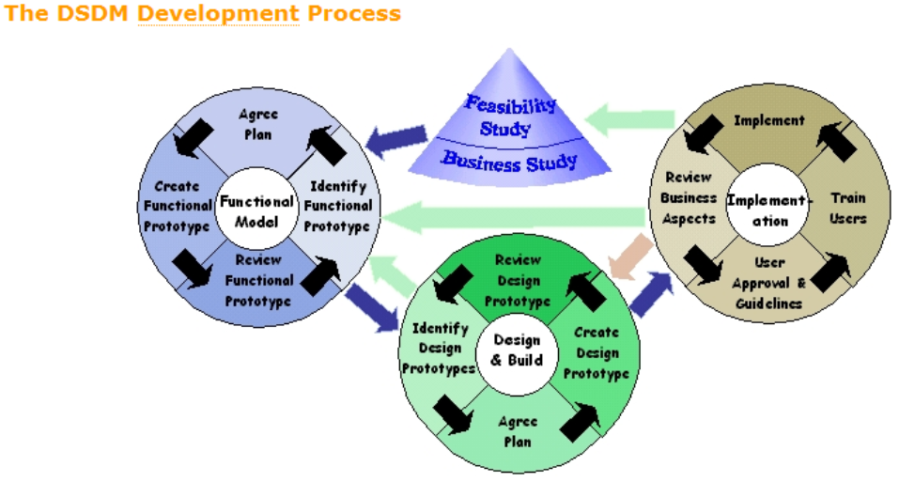

DSDM is a proven framework for Agile project management and delivery, helping to deliver results quickly and effectively and, over the years, has been applied to a wide range of projects - from small software developments all the way up to full-scale business process change.

Although DSDM works easily and effectively on small, simple projects, it has always maintained a strong focus on the corporate project-based environment to provide a “grownup” approach to Agile in the complex corporate world.

Managing any business change or developing any solution is rarely a simple task. Certain problems occur regularly whenever people from multiple disciplines work together on a project.

DSDM is specifically designed to address many of these well-known problems. The following are seen as the key problems.

* COMMUNICATION PROBLEMS
* LATE DELIVERY
* THE DELIVERED SOLUTION ISN’T REALLY WHAT THE BUSINESS WANTED
* UNUSED FEATURES
* BUILDING THE RIGHT THING – THE BUSINESS CHANGING THEIR MIND
* DELAYED OR LATE RETURN ON INVESTMENT (ROI)
* OVER-ENGINEERING (‘GOLD PLATING’)
* “Fragile” Agile
* Waterfall dressed up as Agile

Using iterative development, Atern involves the solution’s end-users throughout the project lifecycle. This has many benefits, for example:

* the users are more likely to claim ownership of the solution
* the risk of building the wrong solution is greatly reduced
* the final solution is more likely to meet the users’ real business requirements
* the users will be better trained, since their representatives will define and co-ordinate the training required
* Deployment is more likely to go smoothly, because of the co-operation of all parties concerned throughout development.

Atern specifically addresses many of the problems which cause projects to struggle or to fail. Atern is an agile project delivery framework that delivers the right solution at the right time. The right business solution is delivered because:

* The project team and other significant stakeholders remain focused on the business outcome
* Delivery is on time ensuring an early return on investment
* All people involved with the project work collaboratively to deliver the optimum solution
* Work is prioritized according to business need and the ability of users to accommodate changes in the agreed timescale
* Atern does not compromise on quality, i.e. the solution is not over- or under-engineered

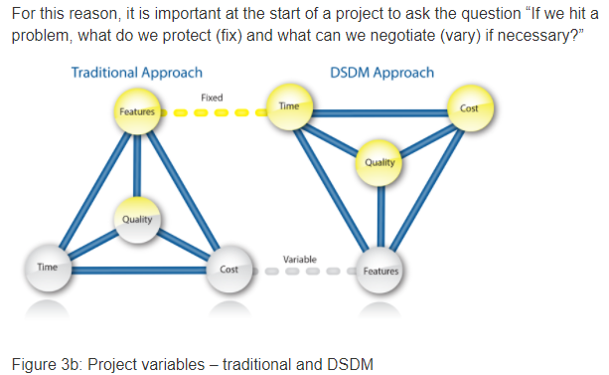

The DSDM philosophy is that

*“best business value emerges when projects are aligned to clear business goals, deliver frequently and involve the collaboration of motivated and empowered people.”*

This is achieved when all stakeholders:

* Understand and buy into the business vision and objectives
* Are empowered to make decisions within their area of expertise
* Collaborate to deliver a fit for purpose business solution
* Collaborate to deliver to agreed timescales in accordance with business priorities
* Accept that change is inevitable as the understanding of the solution grows over time

Stakeholders encompass everybody inside or outside the project who are involved in or affected by it.

DSDM’s approach and style has always been founded on an underlying ethos of common sense and pragmatism. It may be useful to clarify the meaning of these words:

* **Common sense -** “sound practical judgment independent of specialized knowledge or training; normal native intelligence.”
* **Pragmatism -**“action or policy dictated by consideration of the immediate practical consequences rather than by theory or dogma.”

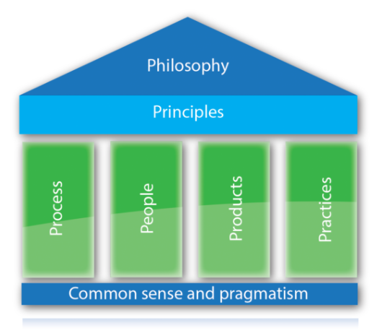

**Atern’s eight Principles are:**

**The eight principles help direct and shape the attitude and mindset of an Atern team. Compromising any of the principles undermines Atern’s philosophy, as together they deliver a collective value that outweighs their individual benefits**

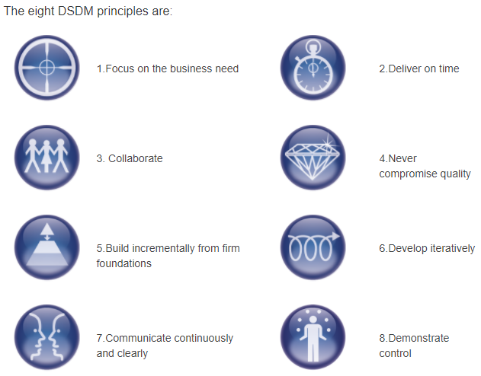

Principle 1 - Focus on the Business Need Every decision taken during a project should be viewed in the light of the overriding project goal - to deliver what the business needs to be delivered, when it needs to be delivered.

It is important to remember that a project is a means to an end, not an end in itself.

In order to fulfil this principle, DSDM teams will:

* Understand the true business priorities
* Establish a valid business case
* Ensure continuous business sponsorship and commitment
* ​​​Guarantee delivery of the Minimum Usable SubseT  
    
  Specific business roles in DSDM, in conjunction with the business products created in the Foundations phase, and key practices such as timeboxing and MoSCoWprioritisation, enable DSDM teams to fulfil this principle.

Principle 2 - Deliver on TimeDelivering a solution on time is a very desirable outcome for a project and is quite often the single most important success factor. Late delivery can often undermine the very rationale for a project, especially where market opportunities or legal deadlines are involved.

Even for projects without a need for a fixedend date, on time delivery of intermediate or contributing products is still the best way to demonstrate control over evolution of the solution.

In order to fulfil this principle, DSDM teams need to:

* Timebox the work
* Focus on business priorities
* Always hit deadlines
* Build confidence through predictable delivery

Combining the DSDM practices of timeboxing and MoSCoW prioritisation enables DSDM teams to protect deadlines whilst flexing the features, and to build a reputationfor timely and predictable delivery. The ability to deliver on time and to meet the prioritised expectations of the business in the short term – the timebox – forms the basisof control over the longer-term deliver y of the project through timely delivery of Increments.

Principle 3 – CollaborateTeams that work in a spirit of active cooperation and commitment will always outperform groups of individuals working only in loose association.

Collaboration encourages increased understanding, greater speed and shared ownership, which enable teams to perform at a level that exceeds the sum of their parts.

In order to fulfil this principle, DSDM teams need to:

* Involve the right stakeholders, at the right time, throughout the project
* Encourage pro-active involvement from the business representatives
* Ensure that all members of the team are empowered to take decisions on behalf of those they represent
* Build a one-team culture

DSDM’s Business Visionary, Business Ambassador and Business Advisor roles bring the appropriate subject matter experts into the project so they can contribute tothe solution.The Solution Development Team brings together business and technical roles in a single team.This one-team culture is fostered by the Business Analyst helping to facilitate business agreement on the requirements and the Team Leader taking responsibility for facilitating a high level of collaboration between all Solution Development Team members. Facilitated workshops enable stakeholders to share their knowledge effectively with other members of the project team.

Principle 4 - Never Compromise Quality In DSDM, the level of quality to be delivered should be agreed at the start. All work should be aimed at achieving that level of quality - no more and no less.

A solution has to be ‘good enough’. If the business agrees that the features in the Minimum Usable SubseT meet the agreed acceptance criteria, then the solution should be ‘good enough’ to use effectively.

In order to fulfil this principle, DSDM teams need to:

* Agree the level of quality from the outset, before development starts
* Ensure that quality does not become a variable
* Test early, test continuously and test to the appropriate level
* Build in quality by constant review
* Design and document appropriately

Ensuring testing is properly integrated into the Iterative Development process, with regular reviews throughout the project lifecycle, helps the DSDM team to build aquality solution. The review and quality control products created as the project proceeds help demonstrate that the quality of the solution is meeting the expected standard.

Using DSDM, everything is tested as early as possible. MoSCoW prioritisation and timeboxing are used to ensure that testing is appropriate and under taken without introducing unnecessary risks. In an IT project, the use of test-driven development techniques can also significantly improve the quality of the solution by ensuring that the acceptability of the solution is understood before development starts.

Principle 5 - Build Incrementally from Firm Foundations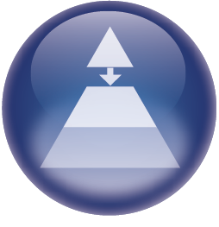One of the key differentiators for DSDM within the Agile space is the concept of establishing firm foundations for the project before committing to significant development. DSDM advocates first understanding the scope of the business problem to be solved and the proposed solution, but not in such detail that theproject becomes paralysed by overly detailed analysis of requirements.

Once firm foundations for development have been established, DSDM advocates incremental deliver y of the solution in order to deliver real business benefit as earlyas is practical. Incremental delivery encourages stakeholder confidence, offering a source of feedback for use in subsequent Timeboxes and may lead to the earlyrealisation of business benefit.

In order to fulfil this principle, DSDM teams need to:

* Carry-out appropriate analysis and enough design up front (EDUF) to create strong foundations
* Formally re-assess priorities and informally re-assess ongoing project viability with each delivered Increment

DSDM teams implement this principle through the appropriate application of a project lifecycle, which delivers a solid base of knowledge during Feasibility and Foundations phases before building the solution incrementally during the Evolutionary Development phase.

Principle 6 - Develop Iteratively DSDM uses a combination of Iterative Development, frequent demonstrations and comprehensive review to encourage timely feedback. Embracing change as part of this evolutionary process allows the team to converge on an accurate business solution.

The concept of iteration is at the heart of everything developed as part of the DSDM approach. It is very rare that anything is created perfectly first time and it is important to recognise that projects operate within a changing world.

In order to fulfil this principle, DSDM teams need to:

* Build business feedback into each iteration
* Recognise that most detail should emerge later rather than sooner
* Embrace change – the right solution will not evolve without it
* Use iterative development to encourage creativity, experimentation and learning

Change is inevitable; DSDM allows for change and harnesses its benefits.

Within the constraints of time and cost, change is actively encouraged in order to evolve the most appropriate solution. DSDM uses iteration and constant review to make sure that what is being developed is what the business really needs. Cycles of feedback should form part of the process for evolving all project deliverables e.g. allplans and documentation.

Principle 7 - Communicate Continuously and Clearly Poor communication is often cited as the biggest single cause of project failure.

DSDM practices are specifically designed to improve communication effectiveness for both teams and individuals.

In order to fulfil this principle, DSDM teams need to:

* Encourage informal, face-to-face communication at all levels
* Run daily team stand-up sessions
* Use Workshops, with a facilitator where appropriate
* Use visual communication practices such as Modelling and Prototyping
* Demonstrate the Evolving Solution early and often
* Keep documentation lean and timely
* Manage the expectations of the stakeholder at all levels throughout the project
* Always aim for honesty and transparency in all communication

DSDM emphasises the value of human interaction through Stand-ups (see Chapter 13 - Timeboxing), Workshops, clearly defined roles and active business involvement.

Modelling and Prototyping make early instances of the solution available for scrutiny. These practices are far more effective than the use of large textual documents, which are sometimes written for reasons other than achieving the business objectives of the project.

Principle 8 - Demonstrate Control It is essential to be in control of a project at all times and to be able to demonstrate that this is the case. This can only be achieved by reference to a plan for the work being done, which is clearly aligned with agreed business objectives.

It is also vital to ensure transparency of all work being performed by the team.

In order to fulfil this principle, DSDM teams, especially the Project Manager and Team Leader, need to:

* Make plans and progress visible to all
* Measure progress through focus on delivery of products rather than completed activities
* Manage proactively
* Evaluate continuing project viability based on the business objectives
* Use an appropriate level of formality for tracking and reporting

The use of well-defined Timeboxes, with constant review points, and the preparation of the Management Foundations and Timebox Plans, are designed to assist the Project Manager and the rest of the project team to follow this principle.

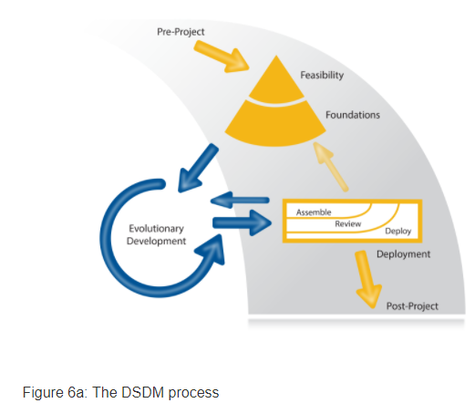

The DSDM process model comprises a framework which shows the DSDM phases and how they relate to one another. This process model is then used by each project to derive their lifecycle.

The project process, as shown in the figure above, has four main phases: Feasibility, Foundations, Evolutionary Development and Deployment. These are preceded by the Pre-Project phase and followed by the Post-Project phase, giving six phases in total.

**Roles and Responsibilities**

People working together effectively are the foundation of any successful project. DSDM recognises this and assigns clear roles and responsibilities to each person in a project, representing the business interests, the solution/technical interests, the management interests and the process interests. Everyone involved in a DSDM project works very closely together in order to break down potential communication barriers.

The best solutions emerge from self-organising, empowered teams. However, these teams, and the people within them, must actively take on the responsibility for their empowerment within the boundaries that have been agreed. At the same time, it is important they:

* Respect each other’s knowledge, experience, skills and opinions
* Take personal responsibility for their work and the dependence of the other team members on them
* Have the courage to challenge ways of working, to improve their team collaboration and working processes**.**

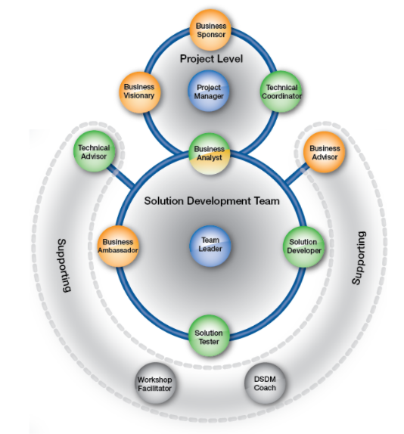

Role colour scheme - to represent areas of interest

The colour scheme in figure 7a is as follows:  
• Orange - Business interests, roles representing the business view  
  
• Typically taken by business personnel, e.g. Business Ambassador providing day-to-day business direction, Business Visionary providing high-level direction and a view of the future.

• Green - Solution/technical interests, roles representing the solution/technical view

• Contributing to the technical development of the solution, e.g. Solution Developers creating the solution, Technical Coordinator providing technical leadership and direction.

• Grey - Process interests, roles representing the process view

• Facilitating the process aspects of the project, e.g. Workshop Facilitator managing the workshop process, DSDM Coach embedding the DSDM framework

• Mix of two colours – A role that straddles two separate areas of interest, e.g. Business Analyst, has both a business and a solution/technical focus

• Blue - Management interests, roles representing the management/leadership view

• Facilitating the management / leadership aspects of the project, e.g. Project Manager and Team Leader following the DSDM process and managing/leading a DSDM project (using Agile leadership competencies)

**Business Sponsor** This role is the most senior project-level business role. The Business Sponsor is the project champion who is committed to the project, to the proposed solution and the approach to delivering it. The Business Sponsor is specifically responsible for the Business Case and project budget throughout (however formally or informally this may be expressed).  
The Business Sponsor must hold a sufficiently high position in the organisation to be able to resolve business issues and make financial decisions. This role has a crucial responsibility to ensure and enable fast progress throughout the project.

The Business Sponsor should be committed, supportive and available for the duration of the project, providing a clear escalation route. On smaller projects, the Business Sponsor role will always be fulfilled by a single person. However, on larger projects or in complex organisations, the Business Sponsor’s financial responsibilities may be fulfilled by a higher authority such as an investment board or an executive committee. In this circumstance, DSDM expects the business to agree a specific person to “front” the role. This ensures the project deals with a single ultimate decision-maker and a single ultimate escalation point, and is protected from a lack of clarity through differing views about the project.

**Business Visionary** This is a senior project-level business role that should be held by a single individual, since a project needs a single clear vision to avoid confusion and misdirection. More actively involved than the Business Sponsor, the Business Visionary is responsible for interpreting the needs of the Business Sponsor, communicating these to the team and, where appropriate, ensuring they are properly represented in the Business Case. The Business Visionary remains involved throughout the project, providing the team with strategic direction and ensuring that the solution delivered will enable the benefits described in the Business Case to be achieved. At the end of the project, the Business Visionary will own the Deployed Solution and will be responsible for the realisation of any benefits associated with it.

**Technical Coordinator**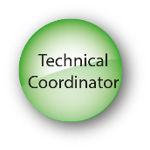As the project’s technical authority, the Technical Coordinator ensures that the solution/technical roles work in a consistent way, that the project is technically coherent and meets the desired technical standards. This role provides the glue that holds the technical aspects of the project together while advising on technical decisions and innovation. The Technical Coordinator performs the same function from a technical perspective as the Business Visionary does from a business perspective.

**Project Manager** 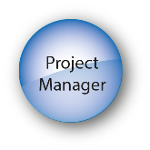As well as providing high-level Agile-style leadership to the Solution Development Team, the role is focused on managing the working environment in which the solution is evolving. The Project Manager also coordinates all aspects of management of the project at a high level but, in line with the DSDM concept of empowerment, the Project Manager is expected to leave the detailed planning of the actual delivery of the product(s) to the members of the Solution Development Team. Managing an empowered team requires a facilitative style rather than a “command and control” style.  
Although the Project Manager role is focused on getting the project delivered, appropriate sourcing of the role will depend on the skills and knowledge required and on the project itself; the Project Manager may come from the business, or may come from the solution/technical side. For some projects, especially formal contractual projects being delivered by external suppliers, there may be two Project Managers, one from the business (the customer) and one from the solution/technical side (the supplier).  
It is usual that the Project Manager takes responsibility throughout the duration of the project. This must include both business and technical delivery aspects of the project, from Foundations (if not Feasibility) through to Deployment.

**Business Analyst** 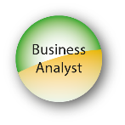The Business Analyst is both active in supporting the project-level roles and fully integrated with the Solution Development Team. The Business Analyst facilitates the relationship between the business and technical roles, ensuring accurate and appropriate decisions are made on the Evolving Solution on a day-to-day basis. The Business Analyst ensures that the business needs are properly modelled and analysed and are correctly reflected in the guidance the team needs to generate the solution.

**Team Leader**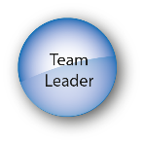The Team Leader ideally acts as the servant-leader for the Solution Development Team and ensures that it functions as a whole and meets its objectives. The Team Leader works with the team to plan and coordinate all aspects of product delivery at the detailed level. This is a leadership role rather than a management role and the person holding it will ideally be elected by his or her peers as the best person to lead them through a particular stage of the project. It is therefore likely that they will also perform another Solution Development Team role (e.g. Business Analyst, Business Ambassador, Solution Developer or Solution Tester) in addition to their team leadership responsibilities. It is also feasible that the person carrying out the Team Leader role could be different from one Timebox to another, for example where they have a different focus.

**Business Ambassador** The Business Ambassador is the key representative of the business needs within the Solution Development Team and, as such, they need to have the desire, authority, responsibility and knowledge to fulfil the role

Business Ambassador role is someone who is already busy. For this reason they must be able to commit the appropriate (and agreed) amount of time throughout Timebox development to help guide the Evolving Solution in the right direction to meet the business needs. For some projects, this may require a full-time commitment as the only way to meet the deadline. However this is unusual and actually introduces a risk that the Business Ambassador may become unaware of events occurring in the business. For most projects, the Business Ambassador commitment is a part-time one, at a level agreed during Foundations. But it is also important that where an Ambassador is committing time to the project, some of their normal workload can be delegated, so that all their work (day-to-day business and DSDM project) can be achieved in a normal working week. It is important that the amount of commitment expected is openly discussed and agreed at a workable level.

**Solution Developer**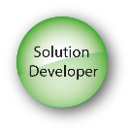The Solution Developer collaborates with the other Solution Development Team roles to interpret business requirements and translate them into a Solution Increment that meets functional and non-functional needs. A person assuming a Solution Developer role needs to be appropriately empowered by the Technical Coordinator to make day-to-day decisions in their area of expertise. They should ideally be allocated full-time to the project they are working on. Where they are not full-time, the project ought to be their first priority. If this cannot be achieved, significant risk is introduced with regard to time boxing. This risk needs to be managed proactively by the Project Manager.

**Solution Tester**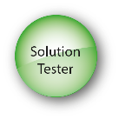The Solution Tester is an empowered Solution Development Team role, fully integrated with the team and performing testing throughout the project in accordance with the agreed strategy.

**Business Advisor**Often a peer of the Business Ambassador, the Business Advisor is called upon to provide specific, and often specialist, input to solution development or solution testing - a business subject matter expert. The Business Advisor will normally be an intended user or beneficiary of the solution or may be a representative of a focus group. However they may, for example, simply provide legal or regulatory advice with which the solution must comply.

**Technical Advisor**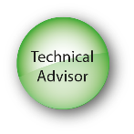The Technical Advisor supports the team by providing specific, and often specialist, technical input to the project, often from the perspective of those responsible for operational change management, operational support, ongoing maintenance of the solution, etc.

**Workshop Facilitator**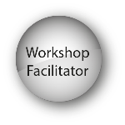The Workshop Facilitator is responsible for managing the workshop process and is the catalyst for preparation and communication.The Facilitator isresponsible for organising and facilitating a session that allows the par participants to achieve the workshop objective.The Workshop Facilitator should be independent of the outcome to be achieved in the workshop

**DSDM Coach**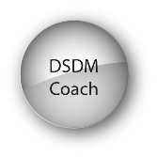Where a team has limited experience of using DSDM, the role of the DSDM Coach is key to helping team members to get the most out of the approach, within the context and constraints of the wider organisation in which they work. The DSDM Coach should ideally be certified as a DSDM Coach to ensure that their competence to fulfil this role has been independently validated.

**PRODUCTS**

The products above are guidelines to the information needed to promote good communication within a project. They are not mandatory, and may not always be presented as documents. However, in circumstances where strong governance and/or proof of compliance with standards is important, there is real benefit to creating formal documents rather than just gaining a shared understanding (which is the normal default for DSDM). Although it may not be obvious, it is important to remember that documentation created as part of the development process and/or tied to the proactive way the project is managed, is likely to provide the most effective and robust audit trail if one is needed.  
It is also critically important to remember that DSDM products are only created if and when they add value to the project and/or to the solution it creates. The most important thing is that the stakeholders and participants in the project understand what is needed and what is being delivered and that quality is assured. If documents genuinely help achieve this then create them, if not, don’t waste valuable time and effort doing so.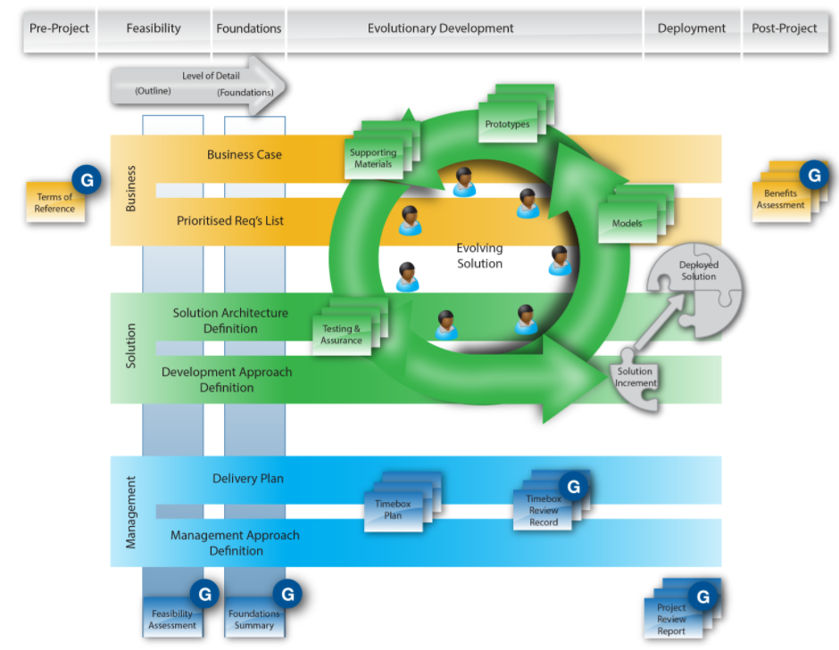

**Facilitated Workshops**

Facilitated Workshops are a specialized type of meeting, with a clear objective (product), a set of people (participants) who are chosen and empowered to produce the product and an independent person (facilitator) to enable the effective achievement of the objective. **The skill and independence of the Workshop Facilitator is important to ensure successful workshops.**

* **Rapid, high quality decision-making**
* **Greater buy-in from all stakeholders**
* **Building team spirit**
* **Building Consensus**
* **Clarification of issues**

The key activities associated with a Facilitated Workshop are:

* Plan the workshop (Workshop Definition)
* Prepare for the workshop
* Facilitate the Workshop Session
  + Run the workshop
  + Review the workshop
* Document the workshop (Workshop Report)
* Follow-up (Post-Workshop Actions and Review)

### **MoSCoW Prioritisation**

In a DSDM project where time has been fixed, it is vital to understand the relative importance of the work to be done in order to make progress and keep to deadlines. Prioritisation can be applied to requirements/User Stories, tasks, products, use cases, acceptance criteria and tests, although it is most commonly applied to requirements/ User Stories. (User Stories are a very effective way of defining requirements in an Agile style;   
MoSCoW is a prioritisation technique for helping to understand and manage priorities. The letters stand for:

* **M**ust Have
* **S**hould Have
* **C**ould Have
* **W**on’t Have this time

**MoSCoW** (Must Have, Should Have, Could Have, Won’t Have this time) is primarily used to prioritise requirements, although the technique is also useful in many other areas. Atern recommends no more than 60% effort for Must Haves for a project, with 40% Shoulds and Coulds. Anything higher than 60% poses a risk to the success and predictability of the project, unless the environment is well understood, the team is established and the external risks are minimal.

**Top Prioritization Tips:**

* **Agree what the priorities mean early in the project**
* **Use all the priorities**
* **Challenge Must Haves**
* **Control the number of Must Haves**
* **Prioritize everything – it helps the concept become deeply ingrained in the team’s approach.**

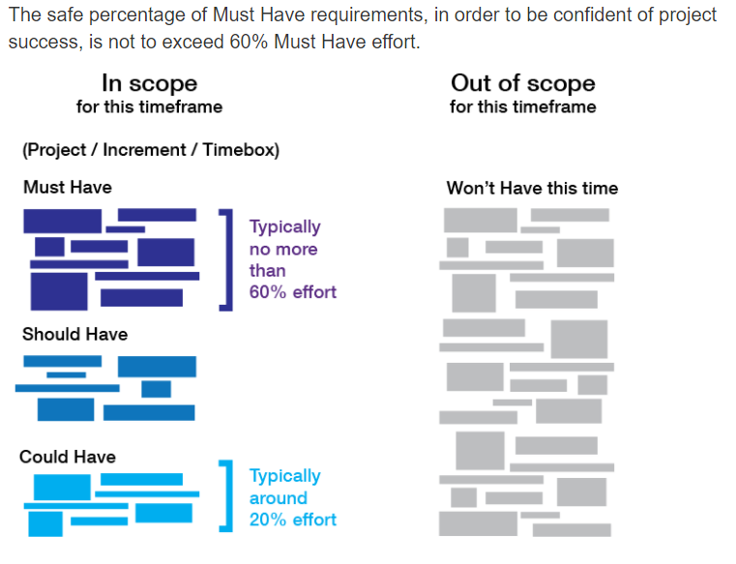

**Iterative Development**

Iterative development is the key technique used by an Atern team to evolve solutions from a high-level idea to a delivered product. The Evolving Solution is the main Atern product that is subjected to the Iterative Development process although it is expected that the concepts associated with the technique will be applied to most project deliverables. It enables a growing understanding of the requirement and convergence on an accurate solution.

The iterative cycle is as follows:

* Identify: the team agree the objective of the next evolution of whatever is being developed at the moment.
* Plan: the team work out what needs to be done by whom to meet the current objective.
* Evolve: the planned activities take place in the agreed timescale.
* Review: the results of the activities are checked to see if the objective has been achieved.

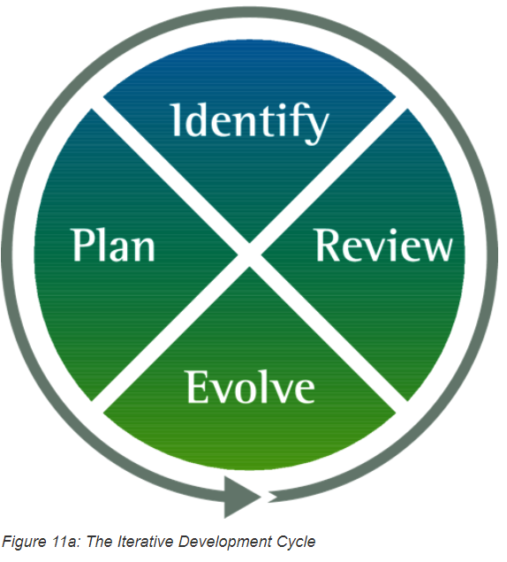

Management of the Iterative Development process as a whole is achieved through the detailed management of various aspects of the project that underpin it. These are:

* Timeboxing
* Change Control (in association with MoSCoW prioritisation)
* Configuration Management
* Quality Assurance of products (including Testing of software products)

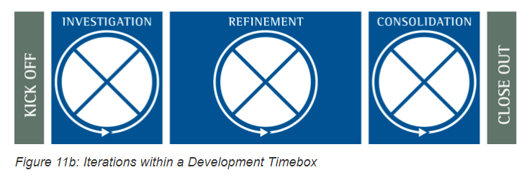

The final consideration in planning an Iterative Development approach is to formulate a strategy to guide the evolution of the solution overall. This strategy is established as part of the Solution Foundations and is a key factor influencing the Delivery Plan.  The approaches to partitioning the development and delivery of the solution are:

* Vertical
* Horizontal
* Combined

It is important to understand the various options available, to ensure the best choice is made for each project.

**Modelling**

Many industries benefit from the use of models, prototypes and mock-ups to establish requirements, confirm expectations and test the achievability of objectives. These can be as different as a storyboard to represent an advertisement or a scale model of a proposed hospital. They can be temporary, transient or throwaway. Atern advocates the use of models to improve communication and to create or challenge ideas by making developing products visible.

**What is a Model?**

A model can variously be defined as:

* a description or analogy used to help visualise something that cannot be directly observed
* a small but exact copy of something
* a pattern or figure of something to be made

Models may be physical (a built version of some part of an eventual solution, for example, working software) or they may be expressed in a language, e.g. a diagramming convention, with its own rules and symbols.

**WHAT**

The information within the solution area, relationships and business rules.

**HOW**

The functions, features and processes within the solution area

**WHERE**

The locations at which the business operates, in relation to the solution area

**WHO**

The people: customers, users, stakeholders

**WHEN**

The events of importance to the business (times and scheduling)

**WHY**

The business objectives and strategy, as related to the project

There are many modelling techniques to choose from, some focusing on a business viewpoint, others used purely for IT. Some of the commonly used techniques are currently:

* Storyboards
* Flowcharts
* Swim-lane diagrams
* Process models
* Class models (IT)
* Use case diagrams (IT)

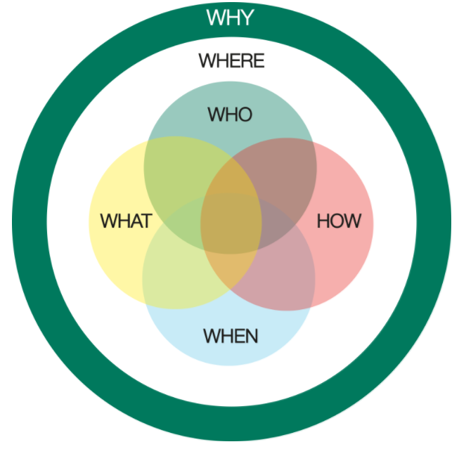

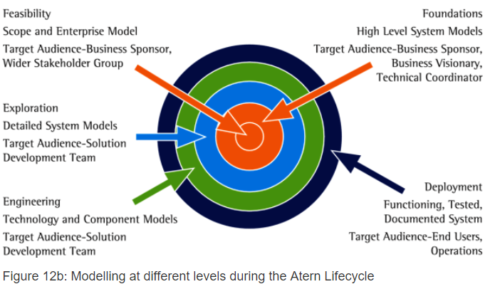

**Timeboxing**

**Timeboxing is a key technique in Atern: it is more than just setting short time periods and partitioning the development work. It is a well defined process to control the creation of low-level products in an iterative fashion, with several specific review points to ensure the quality of those products and the efficiency of the delivery process. By managing on-time delivery at the lowest level, on-time delivery at the higher levels can be assured. Initial MoSCoW prioritisation of the work within the Timebox and continual re-assessment of what can be achieved in the agreed timeframe ensures that Timeboxes finish on time, every time.**

**At the lowest level, the Development Timebox maintains focus on delivery in the short term (weeks or even days). It also provides control at the lowest level, as well as a clear indication of the health of the project. If Development Timeboxes are delivering at least the Must Haves on time every time, then the estimating process is working, the team is working, the Delivery Plan is being validated and the risks should be reducing. This low-level confidence feeds upwards to instil confidence at the increment and the project levels.**

**When creating a schedule of Timeboxes, the primary driver should always be the business priority. However it is advisable to consider other factors when working out a delivery order. Such other factors will include:**

* **Business and technical risk**
* **Solution architecture and external dependencies**
* **Ease of implementation and the drive for an early return on investment**
* **Availability of critical or specialist resources**
* **Constraints associated with business process or corporate policy**
* **Quick wins**

A DSDM structured Timebox comprises three main steps:

* Investigation
* Refinement
* Consolidation

Each of these steps ends with a review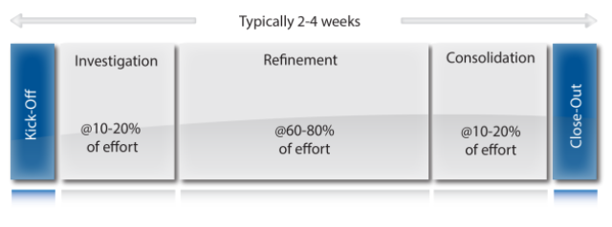

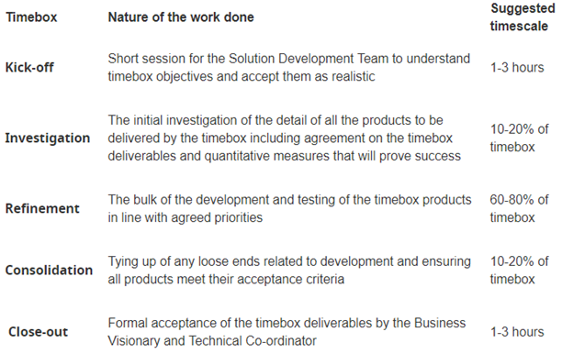

**Requirements**

**What is a requirement?**

At its simplest, a requirement is a service, feature or function that the user wishes the solution to perform or exhibit. Different users may have diverse, even conflicting, perspectives on which requirements should be included and their relative priorities. Atern specifies:

* Business roles to identify who is responsible for defining, agreeing and prioritising requirements
* Facilitated workshops to define and gain buy-in to requirements and to aid resolution of conflicting requirements
* The Prioritised Requirements List to document agreement and assist in the management of the requirements throughout the project
* MoSCoW prioritisation to allow consistent, agreed levels of priority.

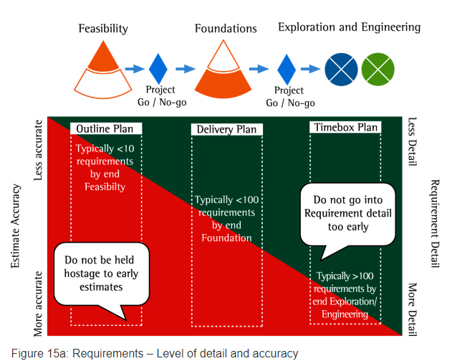

**The Life Cycle of a Requirement**

Any requirement passes through four lifecycle phases:

* **Elicitation** – the requirement is identified, for example during facilitated workshops in the Foundations Phase, with more detail being elicited throughout the lifecycle
* **Analysis** – the requirement is analysed to determine whether it is realistic, ambiguous in any way, or conflicting with other requirements. This will happen during the Foundations Phase, with more detailed requirements being analysed throughout the lifecycle
* **Validation** – the requirement is validated by review and by examination of models of the solution whether in diagrammatic or physical form. This will happen during the Foundations Phase, with more detailed requirements being validated throughout the lifecycle
* **Management** – the requirement is documented in the PRL and any modifications or further subdivisions of the requirement should be traced back to the higher-level requirement they support. This will happen from the point where the highest level requirements are discovered and continue throughout the lifecycle.

The PRL authorizes and documents what is to be included in the plan, together with the priorities. The PRL is an integral planning tool which allows the team to: •

* Establish the basis for agreement between the customers and the suppliers on what the outcome of the project is to be
* Provide a basis for estimating costs and schedules
* Provide a baseline for validation and verification
* Facilitate transfer from old to new working
* Control and enhance the requirements
* Indicate which requirement is anticipated to be in which timebox

**Estimating**

Estimates can be used for several purposes: to evaluate a Business Case, to assess feasibility, to plan project costs and schedules and to communicate with stakeholders. An estimate is a forecast of how much it will take to deliver a specified requirement in terms of cost, effort, skills and duration or, conversely, how much functionality can be delivered for a given cost, effort, skills or duration. Associated with these is a definition of assumptions and risks. Estimating in Atern can use any of the techniques used in other projects but there are four key points:

* Estimates need to include a level of contingency to cover the risk associated with unknown factors. In Atern, contingency is placed in the scope of features to be delivered by applying the MoSCoW prioritisation.
* Estimates are only as precise and accurate as is necessary for their purpose at a given point in the lifecycle.
* Where possible, the people delivering the project carry out the estimate.
* Estimates are expected to be re-validated throughout the project as the understanding of the requirement deepens and as the team’s actual velocity is proven.

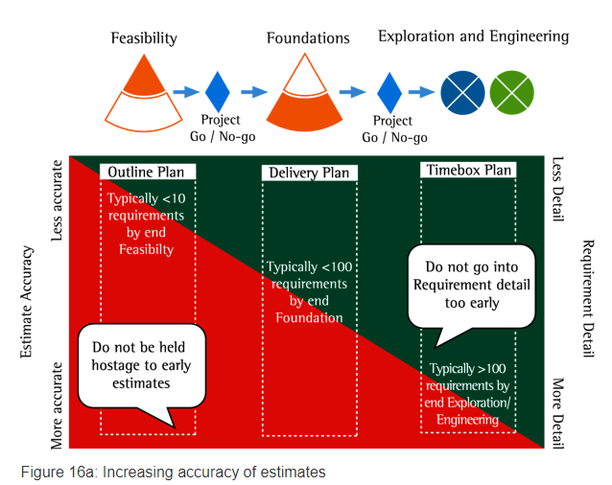**Estimating approach**

**How to estimate – the estimating process**

In simple terms, estimates are created either by assessing the size of the project as a whole or by identifying all its component parts and assessing the sizes of each one. Then the effort required to deliver the various parts is calculated. Following this, the estimate is completed by assessing against reality, cross-checking and documenting.

**Sizing**

There are many ways of breaking a project down into component parts. It may be by tasks, products, use cases, requirements, features or tangible solution components. These components may then be sized either relative to each other or by using standard size and complexity guidelines for components or tasks. For software development projects, function points or use case points may be used to estimate size. These are somewhat different from the above in that they give a single point measure of project size to which a productivity rate may be applied to estimate the total effort required to deliver the project.

**Effort**

Having identified a set of sized components, you then need to estimate the effort required to deliver each. These estimates are always based on experience, whether from individuals, from measures collected on earlier projects or from industry models.

**Team workshop**

One of the best approaches for an Atern project is to hold a team workshop, where those who will be responsible for delivery of the project carry out the estimate. The advantages of this are that it gains commitment and ownership of the estimate and takes account of the team’s skills and capabilities. This is by far the best approach for Development Timebox estimating once the project is under way. The Solution Development Team can modify their estimates to take account of their actual delivery speed (velocity) and their knowledge of the project’s technical and business complexities. The approach may also be used in early estimates (Feasibility and Foundations) where the participants are selected for their relevant technical and business knowledge. During Feasibility and Foundations, the team may need to be supported in this approach by someone with more general estimating knowledge to ensure all aspects of the project are considered.

**Bespoke model**

Many organisations develop estimating models for the types of projects they regularly deliver. These are based on their preferred sizing approach and may use measures gained from experience of previous projects. Advantages are that the models are generally fairly simple and easy to understand and that they can be adapted to meet changing project needs. Disadvantages are that they are reliant on good quality, relevant history from similar previous projects and that they have limited functionality. Such models may be used within the team approach described above and indeed may be created by the team.

**Commercial off-the-shelf tools**

There are many tools available that support estimating, particularly for software development. Most provide industry standard metrics but need to be calibrated for a particular organisation. Advantages are that they provide much greater functionality than bespoke models in exploring options and in presenting the information. Disadvantages are that they must be calibrated before they can be relied on, that there are constraints on the sizing approaches they support, that their relevance is sometimes limited and that they can be expensive. However, they can provide a useful, independent cross-check particularly of an early estimate for a large project.

**Completing the estimate some factors to consider are as follows.**

**Solution Development Team**

What team is available and what level of skills do they have? Generally a team estimate takes this into account, but in an estimating model you will need to set the right levels. How much time will the team actually be able to spend on delivering the identified products? Will they have other activities to do such as administration or career management, other projects to work on, holidays, part-time work? Even if working on one project, time is lost in switching between different tasks, especially if there are more than two.

**Tasks and products**

Have all activities been included, e.g. preparing for workshops, technical support, project management, stakeholder management, communications, reviews and so on?

**Duration**

Based on the realistic estimate of effort required and the team size and availability, the expected duration of the project can be estimated. It is wise to consider the best and worst cases, taking risk into account. Estimating duration is closely related to the project plan in that it should take account such things as delivery approach, parallel working, incremental delivery.

**Costs**

Costs for the project team are based on the expected effort, modified by the practical allocation of team members, e.g. a resource may need to be allocated full time throughout even though the estimated effort would be only four days a week. Other costs may need to be added, e.g. for lease of buildings, provision of office facilities, hardware, third party services etc.

**Cross checking and challenging**

Estimates should always be challenged by independent review and/or by using more than one approach. Using a team approach has a built-in review but it is still valuable to have an independent check. This is of most importance with early project estimates, which are usually based on less detailed information and lack the benefit or prior experience.

**Documentation**

An estimate is not just the final number. It must be supported with enough information to be able to justify it, refine it, qualify it and repeat it. This includes a statement of scope, assumptions, dependencies, detail of calculations, source information, risks, the approach used and related documents. It is often useful to provide a degree of confidence in the estimate based on the amount of knowns and unknowns. The level of documentation must be appropriate to the project; enough to meet project needs and no more.

### The Control Parameters

There are several controls that are available to the Project Manager for monitoring progress and ensuring the project is on a safe course towards its goal. The controls that are most frequently used are:

* Risk
* Business benefit
* Quality
* Resource
* Time
* Cost
* Features

Mechanisms of Control

In Atern, business users and solution developers collaborate to produce a solution that both meets the business need and is maintainable. This requires a change of style for those Project Managers who are used to controlling their developers tightly. Atern employs an empowered teams approach to task allocation and control. Team members organise their own work and, since the Solution Development Team includes the Business Ambassador role, close liaison with the business is an integral part of this. Traditional Project Managers can sometimes feel very uncomfortable with the business/developer consensus approach taken in Atern projects. Indeed enabling the day-to-day activities in an Atern project can be challenging for any project manager.

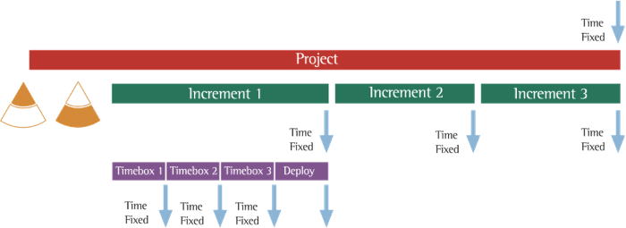

**Adjusting the Controls**

A Project Manager may see his/her role as constantly reacting to issues and therefore adjusting the controls defined above to re-steer the project. The Atern Project Manager must resist the temptation to over-control and over-react. He/she should set the objectives for the teams but leave them to get on with it unless the controls exceed any tolerances that may have been set by the project’s governing body (e.g. a project board or steering committee). So what does this mean in terms of Atern controls?

**Time/Cost**

Atern says that time is sacrosanct and therefore cannot be adjusted! Development Timeboxes and increments are planned to deliver the business benefits for the project via the production of features. Timeboxes that are not delivering as many features as anticipated could indicate that the original estimates of the project are incorrect. This can have two potential consequences:

* The project can deliver the MUSTs (Minimal Usable Subset) but not all the Shoulds and Coulds. In fact, this is fine. This is exactly what we have said in Atern. The Project Manager should still re-examine the estimates and the timebox plans to ensure that the project is optimised to deliver the MUSTs. A note to the project’s governing body would also be in order, although at this stage the project has not exceeded its tolerances
* The project is not delivering the Musts in a timebox. This is a significant issue to be dealt with as early as possible (and the timebox paradigm allows it to be dealt with early). The estimates will have been based on a guess at how fast the team can produce deliverables (velocity), normally based on previous experiences. Any team will need to get up to speed so this must be taken into account when looking at the problem. However, if
* Can we reduce the scope?
* Do we stop the project and re-plan?

Extending the timescale is not an option!

**Resource**

Atern also tells us to fix resource. Adding resource to a project that is perhaps struggling very rarely helps and in fact can adversely affect performance, as the resources who have been delivering take time out to bring newcomers up to speed. The exception is when the project needs specialist skills etc. for a short period. The Project Manager can facilitate the acquisition of such resource. If the team really believes adding resource will help to overcome any issues, then it can be considered but only after checking whether the scope can be reduced and this decision is always an issue requiring escalation.

**Features**

This is the key control that can be adjusted in Atern. The empowerment of the teams means that they will be responsible, daily and during the start up and close down of Development Timeboxes, for appropriate level decisions about features. Addition of lower level Must Haves have to result in the exclusion of other lower level Must Haves. The appropriate level will have been defined by the Prioritised Requirements List developed during the Foundations. Major changes at this level will require escalation to the Project Manager and probably to the project board.

**Quality**

Once the quality required for a project has been agreed (by the end of Foundations), this control cannot be adjusted. Omission of features, provided the Minimum Usable Subset is still intact, is not seen as lowering the quality. See the section on Quality for more details on the concept.

**Dealing with Issues**

The key responsibility for the Atern Project Manager is to deal with issues that can affect the timely delivery of products. Atern projects move quickly and any issues requiring resolution must also be dealt with quickly, otherwise they will adversely affect productivity. This means following a similar process to below:

* Capture the issue (through emails, daily stand-ups, conversations etc.)
* Initiate actions to investigate the issue – is it a real issue, a risk, something requiring a decision?
* Take appropriate action as soon as possible – this may include escalation
* Document the issue and the action taken to avoid recurrence

The documentation can be done at any time and may help to keep the issue under control (for instance, using an electronic issues tracking log on the project). However, the resolution of the issue should not be jeopardised by the documentation!

**Communication is the Key**

Communication failures are a leading contributor to project failures. In fact, project management author Francis Hartman observes from a study of many failed projects, that some form of communication failure is, more often than not, behind project failures.

Traditional software projects often seem to enter a black hole, where, following an initial liaison with the stakeholders, the developers go away for weeks or months at a time before returning with something that barely meets requirements. This makes the Project Manager’s life extremely difficult, providing little in the way of concrete milestones against which progress can really be measured and demonstrated to project stakeholders. Avoiding communication failures should be a high priority for Project Managers. The Atern framework provides several built-in techniques to promote inter-team and stakeholder communication that are described below.

**Facilitated Workshops**

Discussing requirements in the presence of other project stakeholders increases the whole group’s awareness around the project and promotes communications. It also prevents personal wish-lists of goldplated requirements emerging that do not serve the business goals. If asked to list requirements in the presence of peers, fewer unnecessary wish-list items are generated. As questions emerge and are answered, people become aware of differing areas of expertise amongst stakeholders and new communication channels are formed. This does not occur when requirements are elicited one-on-one via interviews or in small meetings.

**Daily Stand-ups**

On a daily basis, each of the members of the team working in a Timebox provides short progress reports and raises any issues that are hindering their progress. This allows all the team members to understand what other people are doing, prevents duplicated effort and enables them to resolve one another’s problems.

**Review Sessions (Prototype, Solution, Timebox)**

Meeting with the Business Ambassador and key representatives (Business Visionary, Business Advisors) at the key control points (start and end of Investigation, Refinement and Consolidation) as well as at the end of every timebox to review progress and features is a major communications enhancer. Evaluating implemented features bridges the gulf that can form between business descriptions (specifications) and developer interpretations. By regularly getting together to review and discuss the evolving solution, stakeholder expectations are reiterated, Solution Development Team understanding is validated and true project progress is communicated. These regular reviews of features with the business/user representatives mitigate a large proportion of project miscommunications. Issues are uncovered early, while there is still time to fix them, new and evolving requirements are identified by the business and opportunities for misunderstanding are minimised through demonstrations of features.

**Frequent delivery of products**

Early and frequent demonstration of product features that can be test driven by the Business Ambassador or Business Advisors gives more visibility to the project and provides timely feedback which is beneficial in enabling all stakeholders to remain engaged in the project. The business can see the solution develop before them and have real power to change its course to meet real business requirements (which may actually change during the development lifecycle). As a result, senior stakeholders and the Atern Project Manager have a tangible and real gauge by which to measure the project’s progress and together with a strong sense of how the project is tracking.

**Stakeholder Communication**

Those close to the Atern project will understand where the project is and how it is progressing. However, it is still necessary to communicate to those less involved. This communication should not be seen as onerous but will be necessary. It is good practice to consider and plan the wider stakeholder communication before the end of the Foundations stage.

**Effective Communication**

Teams may benefit from some short sessions to explore the way they communicate or possibly from some behavioural coaching. In any case, the way in which the team communicates and the effectiveness of their communication, both internally and with those outside the team, should be a key part of the retrospectives held throughout the project, evaluating soft skills such as:

* Listening
* Cooperation, compromise, negotiation
* Open, honest, transparent interactions
* Non-verbal communication, e.g. body language, tone of voice etc.
* Self-awareness
* Appreciation of others, empathy

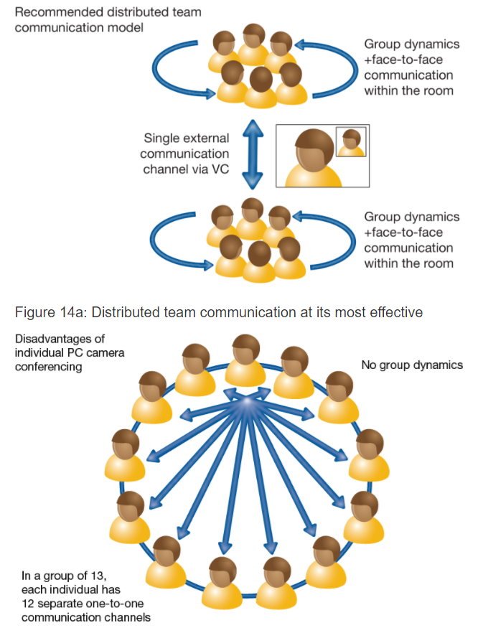

**Escalation in Atern projects**

Escalation can occur in every project when situations develop that make reaching the projected results difficult or impossible. This can occur at different hierarchical levels within the project. The necessary decision-makers then jointly determine whether or not to change the parameters of the project (usually time, scope or budget) in order to create a feasible (sub) project while maintaining coherence. One advantage of Atern’s team structure is the Business Visionary’s ongoing involvement. This means that issues can often be resolved through discussion with the Visionary, thus avoiding formal escalation. In Atern projects, usually there are three decision levels, as shown below: these are steering level, project level and team level. Where an Atern project is part of a multi-project or a programme, more levels may occur.

| **Level** | **Decision Topic** |
| --- | --- |
| Steering | Project Scope (goals and high level results), time, budget, high-level resources, other management constraints  Defined in the Outline Plan, Management Foundations and Delivery Plan products |
| Project | Approach, phasing, increments strategy, functional and non-functional requirements at a high level, intermediate results, resources, technical architecture, technical guidelines  Defined in the Management and Solution Foundations products (including, where applicable, the Business Area Definition, System Architecture Definition and Development Approach Definition) |
| Team | Daily and weekly planning, decisions on who does what, low-level functional and non- functional requirements, the approach to delivering results  Embedded in Timebox Plans and various aspects of the Evolving Solution |

Decision Levels

What should happen when an escalation occurs in Atern projects? Speed of decision making, empowerment and a cooperative and collaborative approach are key to what happens next.

1. The person or group who wants to escalate has to decide whether there is something they can do within their own empowerment (their personal terms of reference) to secure the situation (i.e. it is not worth escalating).
2. If the issue has to be escalated, the next level in the chain should immediately be alerted and the team currently handling the issue should prepare a description of the situation, possible hazards, possible solutions outside the current mandate and recommendations to be formally presented (either in writing or by a structured face-to-face presentation). It might be useful to write a note encapsulating this because formalising the issue helps structure it and may expose a hitherto unconsidered solution within the current remit of the owning team.
3. Within 48 hours (or within the previously agreed timescale for resolving escalated issues), the next level jointly decides upon what action is required. It is essential that all parties to the decision are sufficiently empowered to make the decision work. The decision could be either to escalate up the management hierarchy, or to solve the problem: waiting is not an option. The decision reached has to be carefully documented, together with the main reasons why the decision was reached and which actions should be taken by whom in order to implement the decision.

While the problem is being escalated, the team(s) involved should concentrate on consolidating results or on activities that are not influenced by the decision at hand. In this way, no time is wasted.

**Risk Management**

A project risk is something that may happen and, if it does, it will have a detrimental effect. The following diagram shows a typical risk management process.

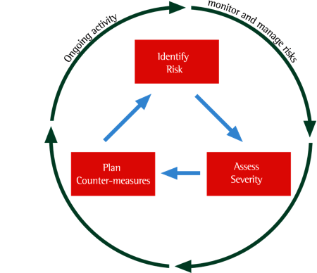

Figure 22a : A typical risk management process

This process ensures that all project risks are identified, assessed and managed. It also helps to manage project risk proactively. This is done by reducing the probability of a risk occurring, identifying contingency plans where needed and at times justifying that a risk is accepted. Countermeasures (mitigation) should be considered for every risk. The nature and extent of the countermeasure will depend on the nature of the risk and on the impact assessment carried out. Countermeasures must be noted in the Risk Log and included in the Delivery Plan and/or Timebox Plans, either as specific actions to prevent or reduce the risk or through re-balancing the MoSCoW priorities in order to deal with risk. Contingency plans should be linked to specific risks. So in a Timebox where significant risk has been identified, it is advisable to increase the proportion of Should Have and Could Have requirements providing additional contingency for the guaranteed delivery of the Must Have requirements There is a perception to that risk management is a Project Manager responsibility. However in reality, the whole team should be aware of the risks, even though the Project Manager may drive risk management. Since the focus of the project is on delivering a business solution and the risks could affect the success of the project, a decision to cancel a project, especially during the early stages, is sometimes made based on an unacceptably high level of risk.

The following table shows some typical situations which can exist on a project and how using Atern can reduce these risks.

| **Situation** | **Why this risk is reduced in Atern** |
| --- | --- |
| The business don’t know exactly what they want | Being unsure of the solution detail in the early stages of the project is seen as normal. From the high-level baseline created during Foundations, the detail emerges through Iterative Development.  Supporting this emerging understanding, Atern’s focus on continuous and clear communication (workshops, modelling, prototyping) allows the team (including the Business roles) to work together to agree the detail. |
| The business change their minds | Within Atern, change is seen as a fact of life and the power of change is harnessed by the team to ensure the solution is correct at the point of delivery, in other words, the solution works the way the business needs it to work. Since there is no detailed signed-off specification and the lowest level of detail is only agreed as late as possible, many ‘changes’ do not affect the project at all. Where change is needed, this is normally encompassed within the Timebox and MoSCoW prioritisation process. |
| Not having all the detail agreed at the start | Atern’s principle of ‘Build from Firm Foundations’ ensures Enough Design Up Front (EDUF) is done to allow the project to move safely forward. It also ensures that a clear high-level baseline is created, to enable control of scope. |
| Unwillingness to commit to final sign-off | Using Atern’s Development Timeboxes, the business accepts the evolving solution incrementally. Therefore achieving final sign-off poses no risk, since this is simply the final step in a gradual process. |
| Late delivery | The whole Atern approach is designed to deliver the right solution on time.Therefore for an Atern project, having a fixed deadline is seen as a benefit, rather than a risk. A fixed and immovable deadline means that everyone stays focused on what is truly important – meeting the deadlines. Contingency, in the form of MoSCoWed features ensures the deadline remains achievable. |

However, the corollary of this is that successful Atern relies on certain practices and behaviours which, if missing or mis-used, can introduce risks. The following table shows risks to Atern that should be assessed at the start of the project.

| **Situation** | **Why is this a risk?** | **Mitigation** |
| --- | --- | --- |
| Low or patchy availability of Business roles | Atern relies on having appropriate input from the Business Ambassador during evolution of the solution detail. If the Business Ambassador regularly misses sessions, the rest of the Solution Development Team are unlikely to deliver the right solution. This will lead to the need for late re-work and hence time and/or cost overruns | In the early lifecycle phases (at the latest by the end of Foundations), define and agree the level of commitment needed. An informal contract of engagement can be helpful, as it highlights as soon as business availability drops below the expected level. It is important to note that Atern does not necessarily require more business involvement than traditional approaches. It does however require that effort to be distributed throughout the project rather than being concentrated in the early (specification) and late (testing) phases of the project |
| Having a fully detailed specification | Atern uses Iterative Development, MoSCoW and Timeboxing to converge on an accurate solution. Where a fully detailed specification already exists, the benefits of the Atern approach with its inherent flexibility may be limited. | Where possible, try to introduce the concept of Atern before time and effort is spent producing a detailed specification (many business do this because they did not realise that other options are available).  Having said that, it is important to consider the risk associated with the accuracy of the specification – unchanged it will rarely reflect the true business need.The Atern approach can still be used ‘full on’, effectively validating the specification through delivery-focused Development Timeboxes. |
| Expecting the 100% solution | Atern’s approach is based around the idea that Time, Cost and Quality are fixed and contingency is built around the prioritisation of Features. If the business need all features to be delivered, then contingency must be built in to Time and/or Cost instead. | In reality, it may be possible to deliver all requirements at the high level and to achieve contingency within the lower levels of each feature, i.e. all high-level features will be delivered, but the depth of some features may be limited. |
| Swapping resources in and out of the team | The combination of Atern’s small teams (7 +/- 2) and the use of rich communication means that a lot of the team information is known and shared informally, rather than being formally written down. Changing resources means that the newcomer to the team does not understand the background to the decisions that have been made, nor will he/she have the necessary depth of information. | Where possible, try to ring-fence the team for the duration of the project (this is made easier by the fact that Atern projects are typically short, intense projects and will finish on time).  Where a team change is unavoidable, try to ensure this happens at the end of an increment, since this is a natural partial closure during the project.  The risk of more frequent change than the cases cited above can be mitigated to an extent by the use of diagramming and modelling techniques. It is still possible and valuable to deal with detail as it emerges during the Iterative Development process and in this scenario the models and their review records provide a visible and useful mapping of ‘group knowledge’ |

On an ongoing basis, the whole team should be ensuring that the Atern Principles are being complied with. Since these typify the behaviour needed, breaking any of the principles will immediately put the Atern approach at risk. Atern provides a Project Approach Questionnaire (PAQ) which helps identify potential risk areas. The PAQ should be completed initially during Feasibility and then revisited during Foundations, to see whether the risk profile for the project has changed. The risks identified should then be kept visible and reviewed for every Development Timebox. It is usually appropriate to run a Risk Analysis workshop early on in the project but the same technique can be used at any appropriate time.

**Concepts for Atern testing**

By using the following set of concepts the Atern Solution Development Team can optimise productivity when testing and maximise the features delivered within the Development Timebox.

**Fail fast**

The earlier a defect is found and fixed, the less it costs therefore the aim is to ‘Fail Fast’. There are many areas where Fail Fast can be of benefit throughout the lifecycle:

* Early testing through reviews and inspections of requirements and design products during the Foundation, Exploration and Engineering phases.
* During modelling exercises
* First time execution of the product being built. You don’t necessarily have to wait for a development to be completed – if it is possible to find defects, start testing!
* Regression testing following changes and fixes
* Integration testing is carried out as soon as there is something to integrate, rather than waiting for a critical mass. In particular, deliverables from earlier increments are integrated with current deliverables.

**Collaborative testing**

Effective and productive testing involves the collaboration of all stakeholders on the project to increase the productivity of the test-fix-and-retest cycle. This concept is in line with the Atern principle to Collaborate and should include business and technical, solution development and testing representatives. Ideally teams will be dedicated to the project and collocated for the duration of the Increment or Development Timebox. However if there are challenges around the availability of key staff or if the project team is geographically dispersed (e.g. it includes off-shore teams), then clear working arrangements need to be put in place together with technology, such as videoconferencing, to minimise the impact.

**Repeatable Tests**

Since testing needs to support Atern’s iterative development approach, tests are likely to be run several times before the product can be accepted by the customer. Hence they need to be designed to be repeatable. However Solution Testers should avoid the temptation to waste valuable time and resources by repeating tests unnecessarily. A test management tool can be deployed to record scripts so that they can be re-run as required. A test automation tool can be used to build repeatable test packs to speed up the regression test cycle.

**End-to-End experience**

Collaborative working, modelling and regular demonstrations provide the ability to review the end-to-end experience from an early stage. This will allow changes to be made in order to enhance and maximise the end-to-end experience. Testing the end-to-end experience includes usability testing, process walkthroughs and performance testing.

**Independent testing**

An Atern product should be tested by someone other than its creator. Independent testing ensures that the understanding of a requirement is tested. This is more effective than testing performed by the creator of the product, since the creator is often limited by their own understanding. Active involvement of the business roles in an Atern project ensures that an independent perspective is applied.

**Prioritised tests**

Tests need to be prioritised because it may not be possible to exhaustively test all products to be delivered within a Development Timebox. The primary method of prioritisation will be by using the MoSCoW rules. Each test should be aligned to a requirement which in turn will have a MoSCoW prioritisation. A secondary method of prioritisation should be through Risk-Based Testing (see below).

**Test-Driven development**

Tests are specified before a given product is created. This ensures that the acceptance criteria are confirmed before any effort is wasted on creating the wrong product.

**Risk-Based Testing**

Some tests, if successful, will significantly reduce the risk associated with putting a product ‘live’ while others will provide little value. It is therefore important to run the tests focused on the higher risk areas first rather than run lots of low value tests. Requirements should be risk assessed against the impact of a failure and the probability of failure. The assessment will provide a prioritisation of the tests to be run. Resources and efforts can then be applied to run the most important tests first.

### **Using Atern Key Techniques in Testing**

| **Key Technique** | **Application in Testing** |
| --- | --- |
| Iterative Development | Early testing with the aim of failing fast so that changes and fixes can be applied.  Tests should be repeatable  Collaborative testing to maximise the test-fix/change – retest cycle. Requirements have testable success criteria |
| Timeboxing | Risk-based testing to focus on running the most important tests first Repeatable automated tests to speed up test activity |
| MoSCoW Prioritisation | Tests linked to requirements so that as the scope of features changes tests can be dropped and included quickly |
| Facilitated Workshop | Facilitated Workshops have many applications in testing. For example:   * In Fail Fast for inspections and walkthroughs of processes, documentation and modelling * To create test documentation such as the Business Testing Strategy * To resolve defects found during testing * To assess the risk against a requirement and prioritise associated tests |
| Modelling | Modelling supports the concept to Fail Fast by providing an opportunity to detect defects at an early stage |

### **Testing Products and Testing Roles**

The products associated with software testing in Atern form part of the Solution Review Strategy (defined as part of the Solution Foundations) and the Solution Assurance Pack (created and maintained in later phases). Testing Packs, part of the Solution Assurance Pack, contain the detailed Test Scenarios, Test Plans, Test Scripts and Test Records aligned with the Evolving Solution. Atern makes a clear distinction between Business and Technical Testing with the former being focused on whether the solution does what the business needs it to do and the latter being focused on whether it is doing it in the right way technically. This distinction is reflected in the way the products are structured and the responsibilities of specific roles with regards to those products. The detail and formality associated with the products will be dictated by organisational standards and the size and complexity of the solution being developed. The roles and responsibilities associated with testing should only be changed or tailored after very careful consideration.

| **Business Domain** | **Solution Domain** |
| --- | --- |
| **Products:**  * Business Testing Strategy – describing how business acceptance testing will be conducted throughout the lifecycle * Business Testing Pack containing   + BusinessTest Scenarios – describing the business process contexts of the tests to be carried out   + Business Test Plans – outlining what tests will be carried out when and by whom   + Business Test Scripts – providing detailing step-by-step guidance on how to execute each test   + Business Test Records – capturing the actual results of the test against the desired outcome | **Products:**  * Technical Testing Strategy – describing how the various types of technical testing (unit testing, integration testing etc.) will be conducted throughout the lifecycle. * Technical Testing Pack containing   + TechnicalTest Scenarios – describing   + particular system usage patterns to be tested   + TechnicalTest Plans – outlining what tests will be carried out when and by whom   + Technical Test Scripts – providing detailing step-by-step guidance on how to execute each test   + Technical Test Records – capturing the actual results of the test against the desired outcome |
| **Responsibilities:** Overall responsibility for ensuring that the solution meets the business need lies with the Business Visionary.  Day-to-day business acceptance testing responsibility lies with the Business Ambassador, supported as needed by Business Advisors. | **Responsibilities:** Overall responsibility for ensuring that the solution is technically fit for purpose lies with the Technical Co-ordinator.  Day-to-day technical testing lies with the Solution Developer in the first instance (unit testing their own work) and the Solution Tester thereafter to ensure that the overall solution is properly tested. |

### **Configuration Management**

Formal Configuration Management (CM) of project assets is an essential discipline for all but the very smallest and simplest of endeavours. It involves identifying all the component parts of the evolving solution together with all intermediate and supporting products (such as Atern documents from across the lifecycle), controlling their storage and knowing their status (e.g. draft or accepted) and their interdependencies at all times. It is vital that the way CM is applied fully supports the principles, practices and team behaviours that are required to make the Atern approach successful. The Principles of Atern encapsulate the value of good Configuration Management:

|  |  |
| --- | --- |
| Focus on the business need | On delivery, the business needs a solution that is well defined, properly constructed and internally consistent in the way it does what it needs to do. Good Configuration Management will allow the solution to be formally baselined on delivery and therefore be in a known state. That baseline will encompass all deliverables making up the solution including those intended to help in its use, support and maintenance. |
| Deliver on time | Configuration Management is intended to keep all a projects assets safe and secure. In the event of a problem such as the loss or corruption of part or all of the solution, good Configuration Management will allow the project to fall back to a recent baseline of that solution with minimal loss of time helping the project meet its on-time delivery commitment. |
| Collaborate | It is important that the Configuration Management system supports collaborative working. Configuration items must be available in a known state for review or enhancement by all members of the team. |
| Never compromise quality | Various aspects of the solution, particularly those related to testing and review processes demonstrate how the solution meets the acceptance criteria defined for it. Each baseline of the solution should include deliverables that demonstrate current compliance. Reuse later on should help demonstrate compliance on an ongoing basis. |
| Build incrementally from firm foundations | The incremental nature of the Atern development process requires a baseline of the solution to be created at each point. The business representatives on the project are expected to confirm that the Evolving Solution is fit for purpose. Therefore the process of baselining should not be onerous. |
| Develop iteratively | The iterative nature of the Atern development process may require the team to revert to a previously agreed state (for example, if the work of a given iterative cycle has taken the Evolving Solution in the wrong direction). The ability to constantly baseline and for it to be easy to fall back to previous baselines are essential characteristics of a Configuration Management system to support an Atern project. |
| Communicate continuously and clearly | The ability to summarise the content of a baseline and report on the status of the configuration items in a given baseline is a useful feature of a Configuration Management tool. |
| Demonstrate control | Good Configuration Management is a primary mechanism for demonstrating control in an Atern project, since it proves that the Evolving Solution is in a known state and each baseline is captured. |

### **Configuration Management Strategy**

A configuration management strategy must be decided and documented in the Development Approach element of the Solution Foundations before leaving the Foundations phase. It should be visible to all Solution Developers. At the very least, the strategy should cover the frequency at which changes will be baselined. Examples include:

* baselining as part of continual integration
* baselining every prototype before demonstration
* baselining every prototype after an approval decision
* baselining daily, which enables flexibility but can be very onerous
* baselining software items once they have been unit-tested
* baselining at the end of a Development Timebox. This is the absolute minimum and should only be used if Timeboxes are short. If the project regularly uses Development Timeboxes over three weeks long, then this strategy is not recommende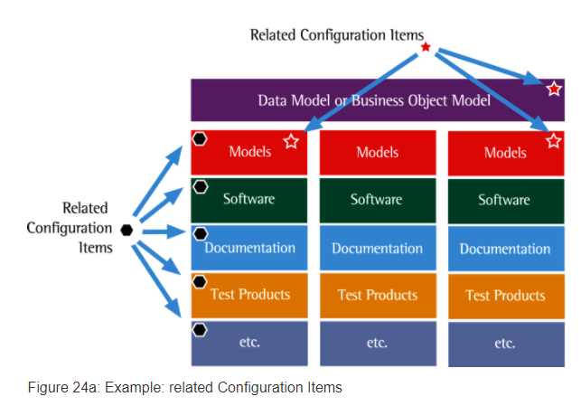

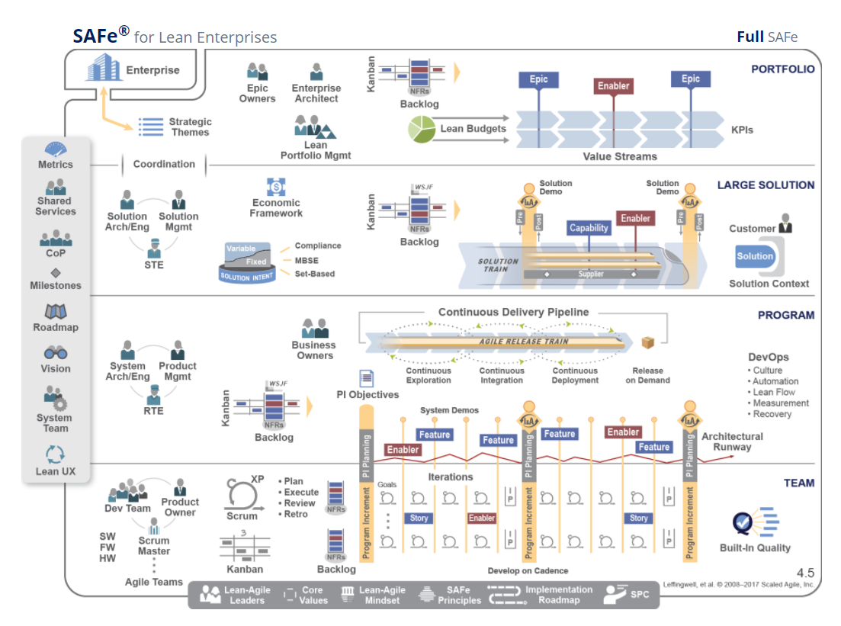

**Metrics** – The primary measure in SAFe is the objective measurement of working solutions. Moreover, SAFe defines some additional intermediate and long-term measures as well, metrics that teams, programs, and portfolios can use to measure progress.

**Shared Services** – Represents the specialty roles that are necessary for the success of an ART or value stream, but that cannot be dedicated full time to any specific train.

**Community of Practice (CoP)** – A community of practice is an informal group of team members and other experts, acting within the context of a program or enterprise, that has a mission of sharing practical knowledge in one or more relevant domains.

**Milestones** – A milestone is used to track progress toward a specific goal or event. These include fixed-date, Program Increment (PI) and learning milestones.

**Roadmap** – The roadmap communicates planned ART and value stream deliverables and milestones over a timeline.

**Vision** – The vision describes a future view of the solution to be developed, reflecting customer and stakeholder needs, as well as Features and Capabilities, which are proposed to address those needs.

**System Team** – This is a special Agile team that provides assistance in building and using the Agile development environment, including Continuous Integration and test automation and automating the delivery pipeline.

**Lean User Experience (UX)** – Lean UX is the application of Lean principles to user experience design. It uses an iterative, hypothesis-driven approach to product development, through constant measurement and learning loops (build-measure-learn). In SAFe, Lean UX is applied at scale, with the right combination of centralized and decentralized UX design and implementation.

**Lean-Agile Leaders** – Management has the ultimate responsibility for business outcomes. Leaders must be trained, and then become trainers of, these leaner ways of thinking and operating. To this end, SAFe describes a new style of leadership exhibited by the enterprise’s leaders.

**Core Values** – Four core values define the belief system for SAFe: Alignment, Built-In Quality, Transparency, and Program Execution.

**Lean-Agile Mindset** – Lean-Agile Leaders are lifelong learners and teachers. They understand and embrace Lean and Agile principles and practices.

**SAFe Principles** – SAFe practices are grounded in nine principles that synthesize Agile methods, Lean product development, systems thinking, and decades of field experience.

**Implementation Roadmap** – Implementing the changes necessary to become a Lean-Agile technology enterprise is a substantial change for most companies. SAFe provides an implementation roadmap to help guide organizations on this journey.

**SAFe Program Consultants (SPCs)** – SPCs are change agents who combine their technical knowledge of SAFe with an intrinsic motivation to improve their company’s software and systems development processes.

Enterprise Architecture Strategy  
  
The enterprise’s ability to embrace organizational change is a key competitive advantage, and the enterprise architectural strategy is a vital element.  
  
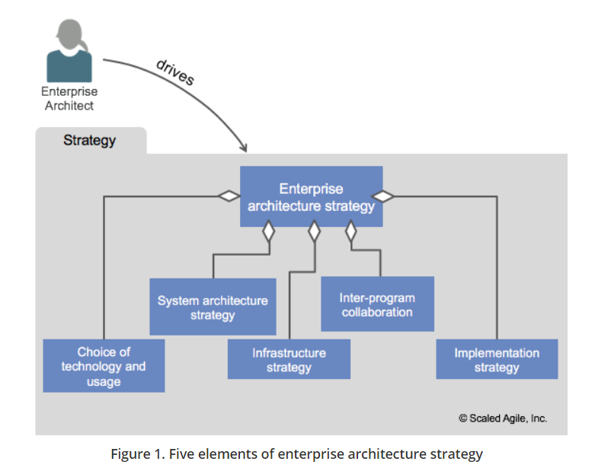

**Choice of technology and usage** – Choosing appropriate technologies is a key element of strategy formulation. Supporting activities include research and prototyping, understanding applicability and scope, and assessing the maturity of innovative new technologies.

**Solution architecture strategy** – The Enterprise Architect works closely with the Solution and System Architects to ensure that individual program and product strategies align with business and technical objectives. For example, emerging solutions to local problems should be consistent with the overall enterprise strategy. When that’s not the case, decisions should be made explicit, as the inconsistent option may well influence future enterprise strategy.

**Infrastructure strategy** – When it fulfills its function properly, development and deployment infrastructure goes unnoticed. However, the strategy for building and maintaining the infrastructure is a key challenge, overlapping with System Architect responsibilities. Some of these responsibilities include the reuse of configuration patterns, common physical infrastructure, knowledge sharing across ARTs and Solution Trains, and—especially—System Teams. In addition, some of the development and deployment infrastructure will likely intersect with internal IT systems. The Enterprise Architect can provide direction there as well.

**Inter-program collaboration** – Various aspects of architecture work occur in different teams and programs. Which is why it’s helpful to ensure that common technology, design practices, and infrastructure are used when applicable. However, it’s also important that value streams and ARTs have sufficient degrees of freedom. Otherwise, innovation decreases. Thus, both common and variable architectural aspects should be actively shared among the ARTs via joint design workshops, design Communities of Practice (CoPs), etc.

**Implementation strategy** – The importance of an effective, incremental Agile implementation strategy can hardly be overstated. Building the technical foundation for business epics into the architectural runway must be an incremental process. Continuous technical learning and fast feedback allow architecture and business functionality to grow synchronously over time. The ability of Agile Teams and programs to refactor as necessary and preserve multiple possible design options wherever practical supports this. Abstraction and generalization help avoid binding specificity too early, which preserves architectural flexibility for future business needs.

**The portfolio Kanban system provides many benefits:**

* It makes the most significant business initiatives visible
* Brings structure to analysis and decision-making for epics
* Work in Process (WIP) limits ensure that the teams responsibly analyze epics
* It prevents unrealistic expectations
* Drives collaboration among the key stakeholders
* They support a transparent and quantitative basis for economic decision-making

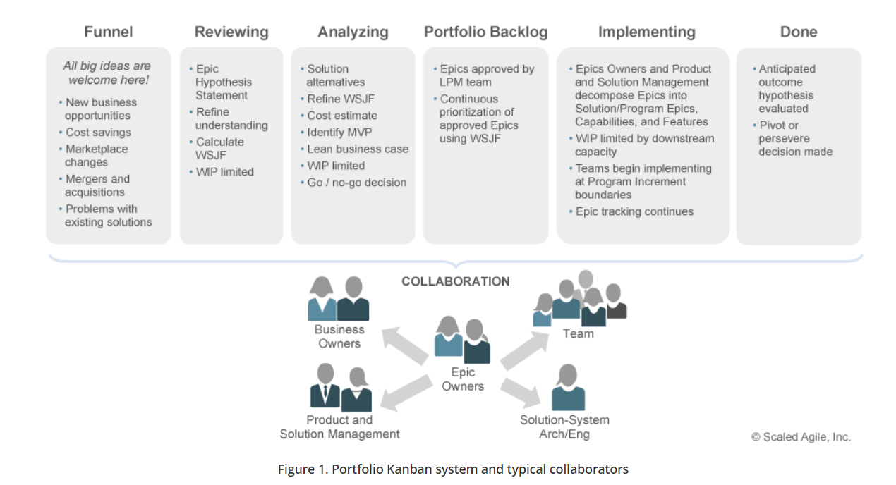

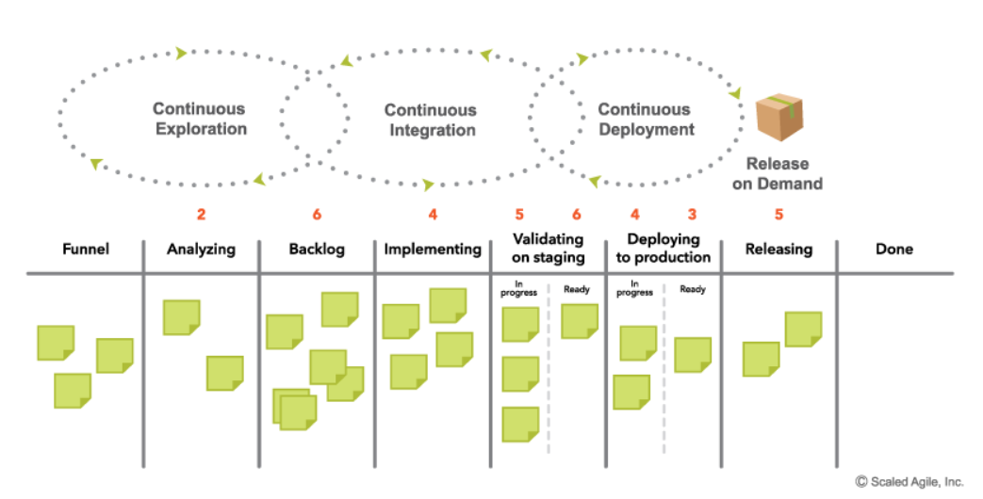

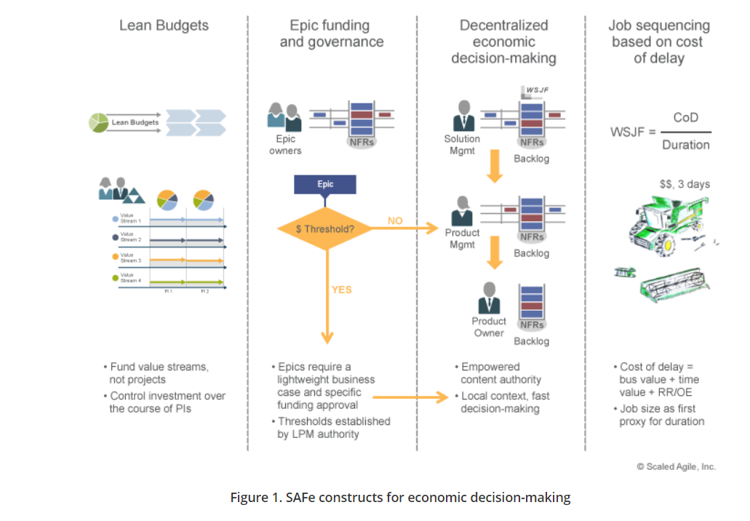

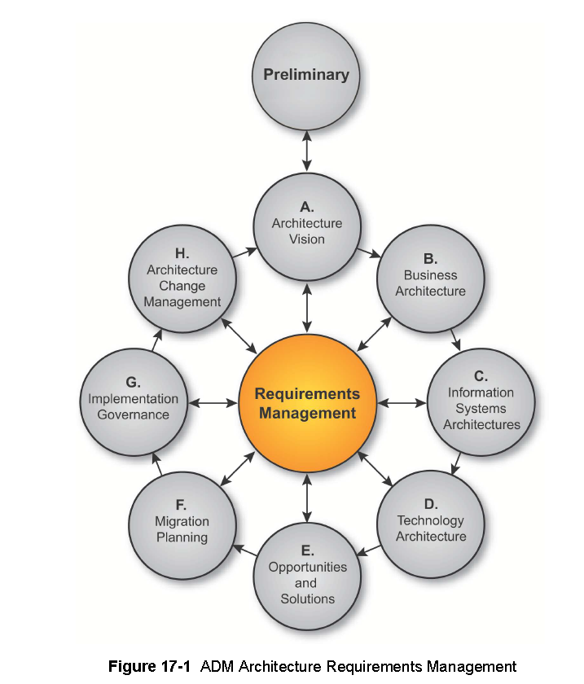

**ADM Guidelines & Techniques to support specific tasks within the ADM:**

**Architecture Principles**— principles for the use and deployment of IT resources across the enterprise — describes how to develop the set of general rules and guidelines for the architecture being developed.

**Stakeholder Management** describes Stakeholder Management, an important discipline that successful architecture practitioners can use to win support for their projects.

**Architecture Patterns** provides guidance on using architectural patterns.

**Business Scenarios** describes the Business Scenarios technique, a method for deriving business requirements for architecture and the implied technical requirements.

**Gap Analysis** describes the technique known as gap analysis. It is widely used in the TOGAF ADM to validate an architecture that is being developed.

**Migration Planning** Techniques describes a number of techniques to support migration planning in Phases E and F.

**Interoperability Requirements** describes a technique for determining Interoperability requirements.

**Business Transformation Readiness Assessment** describes a technique for identifying business transformation issues.

**Risk Management** describes a technique for managing risk during an Architecture / business transformation project.

**Capability-Based Planning** describes the technique of capability-based planning.

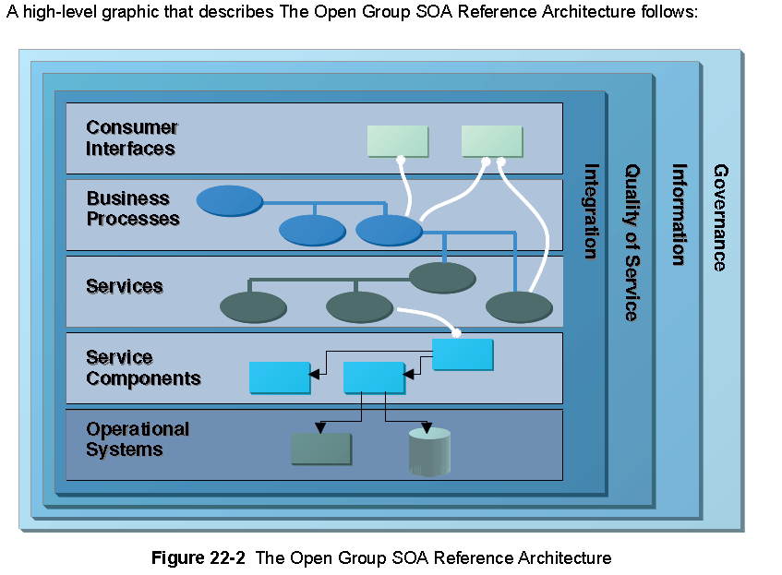

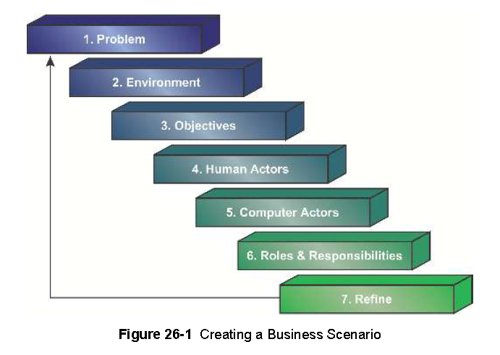 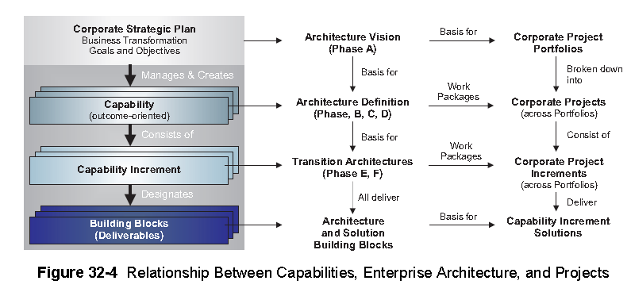

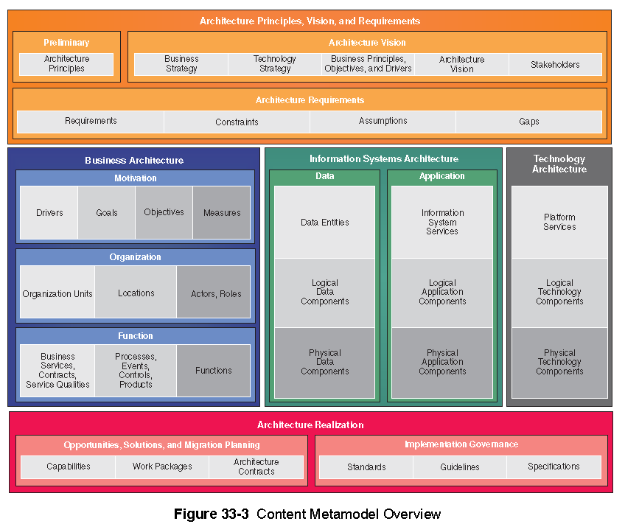

Architecture Principles, Vision, and Requirements artifacts are intended to capture the surrounding context of formal architecture models, including general architecture principles, strategic context that forms input for architecture modeling, and requirements generated from the architecture. The architecture context is typically collected in the Preliminary and Architecture Vision phases.

Business Architecture artifacts capture architectural models of business operation, looking specifically at factors that motivate the enterprise, how the enterprise is organizationally structured, and also what functional capabilities the enterprise has.

Information Systems Architecture artifacts capture architecture models of IT systems, looking at applications and data in line with the TOGAF ADM phases.

Technology Architecture artifacts capture procured technology assets that are used to implement and realize information system solutions.

Architecture Realization artifacts capture change roadmaps showing transition between architecture states and binding statements that are used to steer and govern an implementation of the architecture.

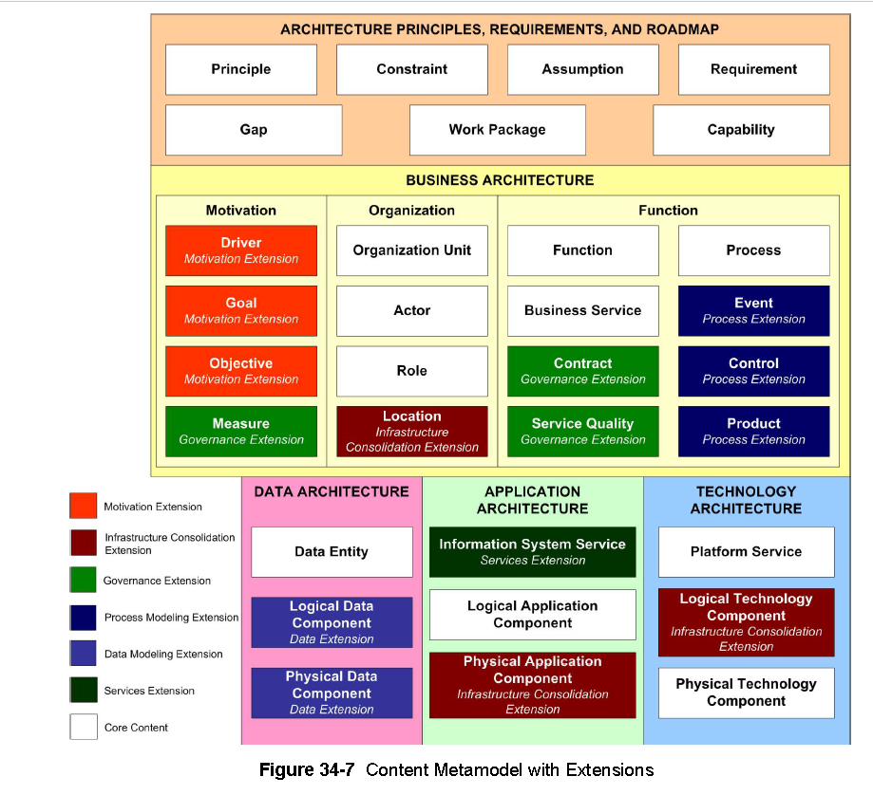

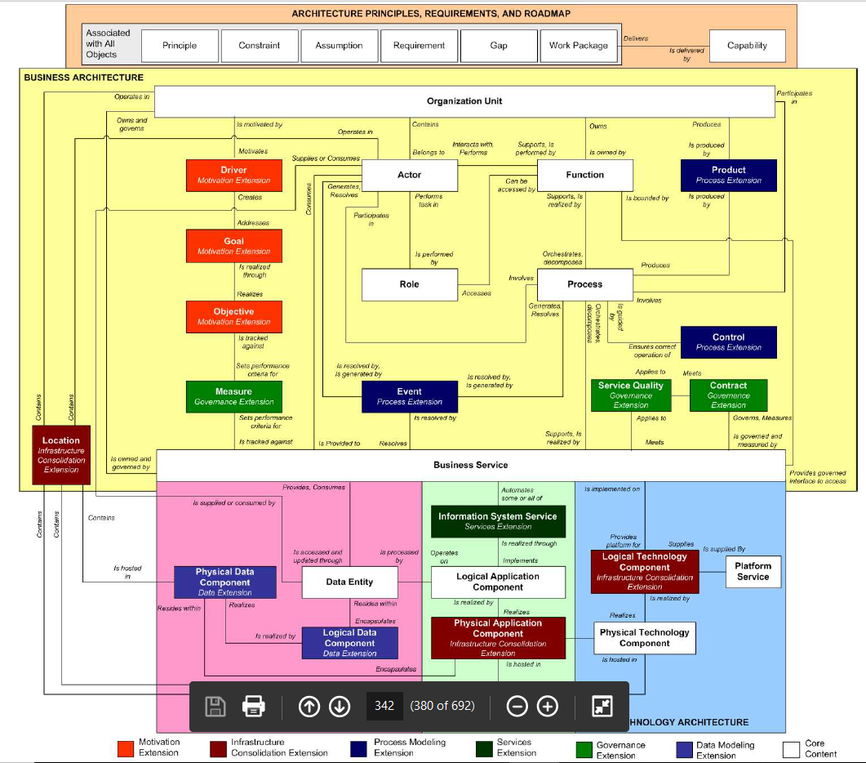

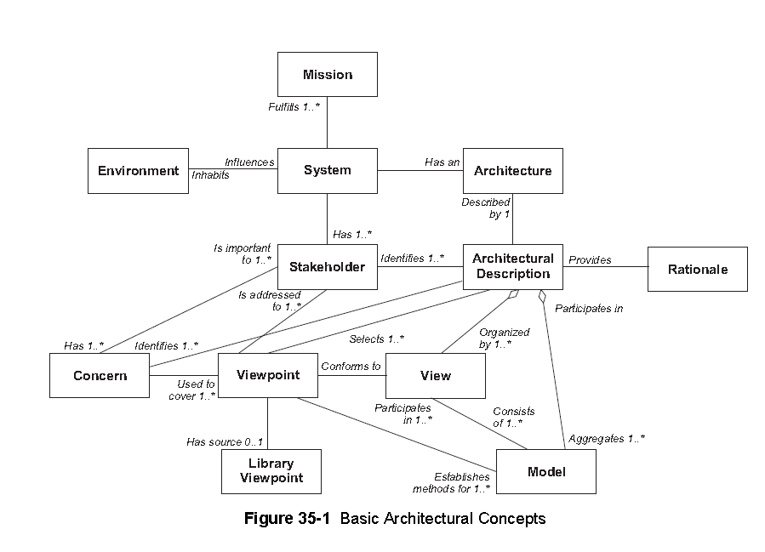

A ‘‘system’’ is a collection of components organized to accomplish a specific function or set of functions.

The ‘‘architecture’’ of a system is the system’s fundamental organization, embodied in its components, their relationships to each other and to the environment, and the principles guiding its design and evolution.

An ‘‘architecture description’’ is a collection of artifacts that document an architecture. In TOGAF, architecture views are the key artifacts in an architecture description.

‘‘Stakeholders’’ are people who have key roles in, or concerns about, the system; for example, as users, developers, or managers. Different stakeholders with different roles in the system will have different concerns. Stakeholders can be individuals, teams, or organizations (or classes thereof).

‘‘Concerns’’ are the key interests that are crucially important to the stakeholders in the system, and determine the acceptability of the system. Concerns may pertain to any aspect of the system’s functioning, development, or operation, including considerations such as performance, reliability, security, distribution, and evolvability.

A ‘‘view’’ is a representation of a whole system from the perspective of a related set of concerns.

In capturing or representing the design of a system architecture, the architect will typically create one or more architecture models, possibly using different tools. A view will comprise selected parts of one or more models, chosen so as to demonstrate to a particular stakeholder or group of stakeholders that their concerns are being adequately addressed in the design of the system architecture.

A ‘‘viewpoint’’ defines the perspective from which a view is taken. More specifically, a viewpoint

Defines: how to construct and use a view (by means of an appropriate schema or template); the information that should appear in the view; the modeling techniques for expressing and analyzing the information; and a rationale for these choices (e.g., by describing the purpose and intended audience of the view).

A view is what you see. A viewpoint is where you are looking from — the vantage point or perspective that determines what you see.

Viewpoints are generic, and can be stored in libraries for re-use. A view is always specific to the architecture for which it is created.

Every view has an associated viewpoint that describes it, at least implicitly. ISO/IEC 42010: 2007 encourages architects to define viewpoints explicitly. Making this distinction between the content and schema of a view may seem at first to be an unnecessary overhead, but it provides a mechanism for re-using viewpoints across different architectures.

In summary, then, architecture views are representations of the overall architecture in terms meaningful to stakeholders. They enable the architecture to be communicated to and understood by the stakeholders, so they can verify that the system will address their concerns.

